

FOR

CONSTRUCTION OF BOUNDARY WALL & SECURITY GUARD POST AT MUNGER TERMINAL.

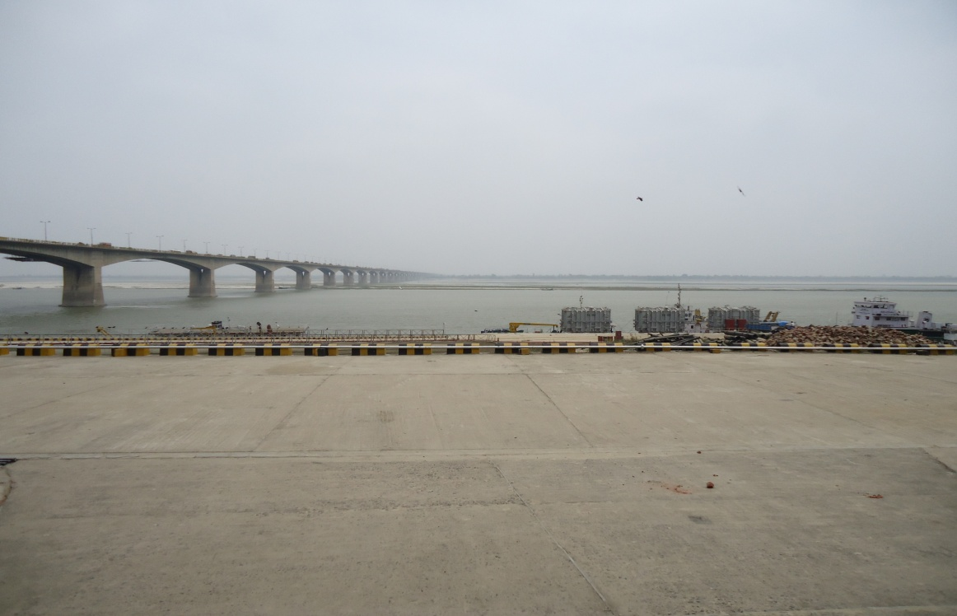

TENDER No. : IWAI-PTN-17(18)/Munger–L/2014-15

INLAND WATERWAYS AUTHORITY OF INDIA
(Ministry of Shipping, Govt. of India)
IWT Terminal, Gaighat, P.O.- Gulzarbagh, Patna - 800 007
Telephone No.0612-2630112/14 & 2630100
Website: http://iwai.gov.in, http://eprocure.gov.in/eprocure/app
E-mail: iwaiptn@rediffmail.com

TENDER ACCEPTANCE LETTER
(To be given on Company Letter Head)

Date:

To,
______________________
______________________
______________________
______________________
______________________

Sub: Acceptance of Terms & Conditions of Tender.

Tender Reference No: ________________________

Name of Tender / Work: - ________________________________________________________________________________________________________________________________________________________
____________________________________________________________________________

Dear Sir,

1. I/ We have downloaded / obtained the tender document(s) for the above mentioned ‘Tender/Work’ from the web site(s) namely: ____________________________________________________________________________
as per your advertisement, given in the above mentioned website(s).

2. I / We hereby certify that I / we have read the entire terms and conditions of the tender documents from Page No. _______ to ______ (including all documents like annexure(s), schedule(s), etc .,), which form part of the contract agreement and I / we shall abide hereby by the terms / conditions / clauses contained therein.

3. The corrigendum(s) issued from time to time by your department/ organization too has also been taken into consideration, while submitting this acceptance letter.

4. I / We hereby unconditionally accept the tender conditions of above mentioned tender document(s) / corrigendum(s) in its totality / entirety.

5. In case any provisions of this tender are found violated , then your department/ organisation shall without prejudice to any other right or remedy be at liberty to reject this tender/bid including the forfeiture of the full said earnest money deposit absolutely.

Yours Faithfully

(Signature of the Bidder, with Official Seal)



Construction of Boundary wall & Security guard post at Munger terminal.

PART – A

TECHNICAL BID

INDEX

SL. NO | DETAILS | PAGE No.
1. | Tender Acceptance letter | 3
2. | PART-A TECHNICAL BID | 4
3. | Index | 5
4. | Notice Inviting Tender (NIT) for Publishing | 6-9
5 | Detailed Notice Inviting Tender | 7-9
6. | Instructions to the Contractors/Bidders for the e-submission | 10-12
7. | Form of Tender | 13-14
8. | Warranty Form | 15
9. | Part-I Information and Instructions for Tenderers | 21
10. | Part-II General Conditions of Contract | 22-48
(i) | Part-III Technical and Special Conditions | 49-53
(ii) | Part-IV Annexure -I Agreement Format | 54-55
(iii) | Annexure – II Bank Guarantee Format | 56-57
(iv) | Annexure – III E-Payment Format | 58
11 | Annexure- IV for Performa of Experience | 59
12 | Annexure - V Drawings | 60-65
13 | Part-IV Bill of Quantity | 66
14 | Part-B Price Bid | 67-68
15 | End of page | 69

NIT FOR PUBLICATION IN NEWSPAPER

Inland Waterways Authority Of India (IWAI) invites Online Bids/Tenders from reputed and experienced Civil contractors for Construction of boundary wall & security guard post at Munger terminal.

1. Date of download the tender documents: From 25/07/2014 to 08/08/2014

2. Last Date & time for submission
of Online Bids/ tender : 08/08/2014 up to 1700 hrs.

3. Date & Time for online opening of Tender: 11/08/2014 at 1530 hrs.

For details visit our web site : - http://iwai.nic.in and
https://eprocure.gov.in/eprocure/app but online submission will be through https://eprocure.gov.in/eprocure/app

Director

INLAND WATERWAYS AUTHORITY OF INDIA
(Ministry of Shipping, Govt. of India)
IWT Terminal, Gaighat, P.O.- Gulzarbagh, Patna - 800 007
Telephone No.0612-26301112/14& 2630100
Web site: http://iwai.gov.in , https://eprocure.gov.in/eprocure/app,
E-mail: iwaiptn@rediffmail.com

DETAILS OF NOTICE INVITING E-TENDER

Tender no.- IWAI-PTN-17(18)/Munger–L/2014-15

IWAI invites Online tender/Bids in two cover system (Cover I - Technical bid and Cover II - Price bid) from reputed & experienced Civil contractor for construction of boundary wall & security guard post at Munger terminal. The Bids will placed online at https://eprocure.gov.in/eprocure/app. Tender document may be downloaded from the https://eprocure.gov.in/eprocure/app. as per the schedule as given in critical date sheet as under:-

Estimated Cost of the work, EMD requirement and Critical Dates are as under:-

Name of Works | Construction of boundary wall & security guard post at Munger terminal
Date of Publishing | 24.07.2014
Document Download Start Date & Time | 25.07.2014 1000Hrs
Pre-Bid Date & Time | Nil
Bid Submission start Date & Time | 25.07.2014 1000Hrs
Bid Closing/Document Download End Date & Time | 08.08.2014 upto 1700Hrs
Bid Opening Date & Time | 11.08.2014 1530Hrs
Estimated Cost(Rs. in Lakhs) | 50.94 Lakhs
Tender Fee( Rs) | 2000.00
EMD (Rs) | 1.02 Lakh

- Bids shall be submitted online only at CPPP website https:\\eprocure.gov.in/eprocure/app Manual bids shall not be accepted and liable to be rejected.

- The Hard Copy of original instruments in respect of cost of tender document, earnest money, other documents in original as asked in this tender document must be delivered at the office of Director, IWAI ,IWT Terminal, Gaighat, Patna-800007 on or before bid closing or opening date/time as mentioned in critical date sheet. Bidder shall likely to be liable for legal action for non-submission of original payment instrument like DD, etc., against the submitted bid. Demand Draft attached/submitted for tender fee shall be non refundable.
- The tenderer shall have to meet the following pre-qualification criteria:

ELIGIBILITY CRITERIA:-

- The firm shall have valid registration in appropriate class with CPWD, MES, Railways or any Central / State Govt. Organization.
- Satisfactory completion of at least three similar/civil works each of value not less than Rs. 20.38 lakhs or two similar works each of value not less than Rs. 25.47 lakhs or one work of value not less than Rs. 40.75 lakhs in last 7 years (year ending March, 2014).
- Similar work shall mean works of Construction of Boundary wall, Sentry Post, Generator room & other developmental works along with fabrication and erection of gate or other civil construction works etc.
- The firm should have average annual financial turnover of Rs. 15.28 lakhs of Construction of Boundary wall, Sentry Post, Generator room & other developmental works along with fabrication and erection of gate other civil construction works etc.
- The firm should not have incurred loss for more than 2 years during preceding five years ending 31st March, 2014.
- The firm shall be working in the field of Construction of Boundary wall, Sentry Post, Generator room & other developmental works along with fabrication and erection of gate or other civil construction works etc.
- The firm should have valid registration for service tax, VAT and should have Permanent Account Number (PAN).

Parties fulfilling the above indicative eligibility criteria can download tender document from the “https://eprocure.gov.in/eprocure/app” and IWAI’s website “www.iwai.nic.in”. Bidders submitting the downloaded version of tender document is required to submit 2000/- (Rupees Two thousand only) i.e. an amount equal to the cost of tender document along with tender in the form of demand draft made in favour of ‘IWAI fund’ payable at Patna at any nationalized/ schedule bank.

A signed declaration stating that no alteration has been made in any form in the downloaded tender document is to be enclosed with the tender by the bidder for downloaded tenders. Site can be inspected on all the working days during office hours. IWAI reserves the right to reject any or all the tender without assigning any reason thereof.

- The firm may quote for work of indicated above and completed bids as per terms &
Conditions mentioned in the tender document should be online submission at
https://eprocure.gov.in/eprocure/app by 1700hrs on 08.08.2014 and it will be
opened on 11.08.14 at 15:30 hrs.

9. For special attention

- All tenderers are cautioned that tenders containing any deviation whatsoever from the terms and conditions, specifications as contained in the tender documents are liable to be rejected as non-responsive.

- The tender shall have to be submitted bid online in two bid format, the first part i.e.” Technical bid” should contain the scanned copy of entire tender document duly signed in all places, details of machineries, technical manpower, work schedule, and earnest money deposit only but not the price bid. Second part i.e.” Financial bid” shall contain only the rates of the item of work as in schedule A these price bid (BOQ of construction of boundary wall & security guard post at Munger terminal) as per format provided along with this tender.

- Each bid shall be submitted in online separate covers super scribing as “technical bid” and “financial bid”.

10. Earnest Money Deposit (EMD) must accompany each tender and tender not accompanied by the EMD shall be rejected as NON-RESPONSIVE. The EMD for an amount as specified above shall be submitted in the technical bid.

11. Opening Of Tenders & Evaluation

- Tenders will be opened online by the tender evaluation committee at IWAI, IWT Terminal cum office, Gaighat, Patna-7 at 15:30 hrs on 11.08.2014 in the presence of representative of the tenders who choose to remain present.
- After the online opening of the tenders, the first part i.e. Technical bid will be evaluated by the Tender Evaluation Committee as constituted by the Authority. The second part i.e. Price bid will be opened online by the same T.E.C. only for those tenderers who become technically qualified after the evaluation of technical on a suitable date.

12. TENDER VALIDITY PERIOD

The tender shall remain valid for a period not less than 90 days after the date of opening of tenders.

Tenderer must read “ Information & Instruction for Tenders” and be satisfied himself in respect to scope and the situation of works or any issue as related to the work as considered necessary before the submission of the tenders.

13. The authority shall have the right to reject any or all the tenders and will not be bound to accept the lowest or any other offer.

DIRECTOR

Instructions to the Contractors/Bidders for the e-submission of the bids online through the Central Public Procurement Portal for eprocurementhttps://eprocure.gov.in/eprocure/app

1) Possession of valid Digital Signature Certificate (DSC) and enrollment/registration of the contractors/bidders on the eprocurement/etender portal is a prerequisite for e-tendering.
- Bidder should do the enrollment in the eProcurement site using the https://eprocure.gov.in/eprocure/app option available on the home page. Portal enrollment is generally free of charge. During enrollment/registration, the bidders should provide the correct/true information including valid email_id. All the correspondence shall be made directly with the contractors/bidders through email_id provided.

3) Bidder need to login to the site thro’ their user ID/ password chosen during enrollment/registration.
4) Then the Digital Signature Certificate (Class II or Class III Certificates with signing key usage) issued by SIFY/TCS/nCode/eMudra or any Certifying Authority recognized by CCA India on eToken/SmartCard, should be registered.

5) The DSC that is registered only should be used by the bidder and should ensure safety of the same.

6) Contractor/Bidder may go through the tenders published on the site and download the required tender documents/schedules for the tenders he/she is interested.

7) After downloading / getting the tender document/schedules, the Bidder should go thro’ them carefully and then submit the documents as asked.

8) If there are any clarifications, this may be obtained online thro’ the tender site, or thro’ the contact details. Bidder should take into account of the corrigendum published before submitting the bids online.

9) Bidder then logs in to the site through the secured log in by giving the user id/ password chosen during enrolment/registration and then by giving the password of the eToken/SmartCard to access DSC.

10) Bidder selects the tender which he/she is interested in by using the search option & then moves it to the ‘my favourites’ folder.

11) From my favourites folder, he selects the tender to view all the details indicated.

12) It is construed that the bidder has read all the terms and conditions before submitting their offer. Bidder should go through the tender schedules carefully and upload the documents as asked; otherwise, the bid will be rejected.

13) Bidder, in advance, should get ready the bid documents to be submitted as indicated in the tender document/schedule and generally, they can be in PDF/xls/rar/jpg/dwf formats. If there is more than one document, they can be clubbed together and can be provided in the requested format. Each document to be uploaded through online for the tenders should be less than 2 MB. If any document is more than 2MB, it can be reduced through zip/rar and the same can be uploaded, if permitted.

14) If there are any clarifications, this may be obtained through the site, or during the pre-bid meeting if any. Bidder should take into account the corrigendum published from time to time before submitting the online bids.

15) The Bidders can update well in advance, the documents such as certificates, annual report details etc., under My Space option and these can be selected as per tender requirements and then send along with bid documents during bid submission. This will facilitate the bid submission process faster by reducing upload time of bids.

16) Bidder should submit the TFee/ EMD as specified in the tender. The original payment instruments should be posted/couriered/given in person to the Tender Inviting Authority within the due date as mentioned in this tender document. Scanned copy of the instrument should be uploaded as part of the offer, if asked for.

17) While submitting the bids online, the bidder reads the terms & conditions and accepts the same to proceed further to submit the bid packets.

18) The bidder has to select the payment option as offline to pay the TFEE/ EMD as applicable and enter details of the instruments.

19) The details of the DD/any other accepted instrument, physically sent, should tally with the details available in the scanned copy and the data entered during bid submission time. Otherwise submitted bid will not be acceptable.

20) The bidder has to digitally sign and upload the required bid documents one by one as indicated. Bidders to note that the very act of using DSC for downloading the bids and uploading their offers shall be deemed to be a confirmation that they have read all sections and pages of the bid document including General conditions of contract without any exception and have understood the entire document and are clear about the requirements of the tender requirements.

21) The bidder has to upload the relevant files required as indicated in the cover content. In case of any irrelevant files, the bid will be rejected.

22) If the price bid format is provided in a spread sheet file like BoQ_xxxx.xls, the rates offered should be entered in the allotted space only and uploaded after filling the relevant coulmns. The PriceBid/BOQ template must not be modified/replaced by the bidder, else the bid submitted is liable to be rejected for this tender.

23) The bidders are requested to submit the bids through online e-tendering system to the Tender Inviting Authority (TIA) well before the bid submission end date & time (as per Server System Clock). The TIA will not be held responsible for any sort of delay or the difficulties faced during the submission of bids online by the bidders at the eleventh hour.

24) After the bid submission, the acknowledgement number, given by the e-tendering system should be printed by the bidder and kept as a record of evidence for online submission of bid for the particular tender and will also act as an entry pass to participate in the bid opening date.

25) The bidder should ensure/see that the bid documents submitted should be free from virus and if the documents could not be opened, due to virus, during tender opening, the bid is likely/liable to be rejected.

26) The time settings fixed in the server side & displayed at the top of the tender site, will be valid for all actions of requesting, bid submission, bid opening etc., in the e-tender system. The bidders should follow this time during bid submission.

27) All the data being entered by the bidders would be encrypted using PKI encryption techniques to ensure the secrecy of the data. The data entered will not viewable by unauthorized persons during bid submission & not be viewable by any one until the time of bid opening.

28) Any bid document that is uploaded to the server is subjected to symmetric encryption using a system generated symmetric key. Further this key is subjected to asymmetric encryption using buyers/bid openers public keys. Overall, the uploaded tender documents become readable only after the tender opening by the authorized bid openers.

29) The confidentiality of the bids is maintained since the secured Socket Layer 128 bit encryption technology is used. Data storage encryption of sensitive fields is done.

30) The bidder should logout of the tendering system using the normal logout option available at the top right hand corner and not by selecting the (X) exit option in the browser.

31) For any queries regarding e-tendering process , the bidders are requested to contact through the modes given below:
E-mail : iwaiptn@rediffmail.com
Contact Telephone Numbers: _0612-2630112 , Fax No. : 0612-2630100 person : Sh. A.K.Singh, Assistant Director

FORM OF TENDER

To,
THE DIRECTOR,
INLAND WATERWAYS AUTHORITY OF INDIA,
GAIGHAT, GULZARBAG
PATNA-800007, BIHAR

Name of Work: Construction of Boundary wall & Security guard post at Munger terminal.

Sir,

1. Having visited the site and examined the information and instructions for submission of tender, general conditions of contract, Special Condition of contracts, Technical, General and Detailed specification, Schedules and Bill of Quantities, agreement and bank guarantee forms, etc for the above named works, I/ We hereby tender for execution of the works referred to in the tender documents in conformity with the said Conditions of Contract, Specifications, Schedule of quantities for the sum as stated in Bill of quantities of this tender Document or such other sum as may be ascertained in accordance with the said conditions of contract.

2. I/ We undertake to complete and Deliver the whole of the works comprised in the Contract within the time as stated in the tender and also in accordance in all respects with the specifications, designs, drawings and instructions as mentioned in the tender documents.

3. I am tendering for the works mentioned in the table below and submitting the EMD for the above work of NW-1 in the form of demand draft in favour of IWAI Fund payable at _______________ at Nationalised / schedule bank as per the details given therein:

Sl.  No | Name work & Location | Demand draft  No. & Date | EMD (Rs.) | Details of Bank  (Name of Bank,  Branch & address)
1 | Construction of boundary wall & Security guard post at Munger terminal

4. I/ We agree to abide by this tender. I/ We agree to keep the tender open for a period of 90 days from the date of opening of price bids or extension thereto as required by the IWAI and not to make any modifications in its terms and conditions.

5. I/ We agree, if I/ we fail to keep the validity of the tender open as aforesaid or I/ we make any modifications in the terms and conditions of my/ our tender if I/ We fail to commence the execution of the works as above, I/ We shall become liable for forfeiture of my/ our Earnest money, as aforesaid and IWAI shall without any prejudice to an other right or remedy, be at the liberty to forfeit the said Earnest Money absolutely otherwise the said earnest money shall be retained by IWAI towards part of security deposit to execute all the works referred to in the tender documents upon the terms and conditions contained or referred to therein and to carry out such deviations as may be ordered. Should this tender be accepted, I/ We agree to abide by and fulfill all the terms and conditions and provisions of this tender. No interest is payable on earnest money deposit and/ or security deposit.

6. I/ We have independently considered the amount of Liquidated Damages shown in the tender hereto and agree that it represents a fair estimate of the loss likely to be suffered by IWAI in the event of works not being completed in time.

7. If this tender is accepted, I/ We undertake to enter into execute at my/ our cost when called upon by the employer to do so, a contract agreement in the prescribed form. Unless and until a formal Agreement is prepared and executed this tender together with your written acceptance thereto shall constitute a binding contract.

8. If my/ our tender is accepted, I/We am/are to be jointly and severely responsible for the due performance of the Contract. I/We also declare that the firm has not been banned or blacklisted by any Govt. or its department or any Quasi Govt. agency or Public Sector Undertaking.

9. I/ We understand that you are not bound to accept the lowest or any tender you may receive and may reject all or any tender without assigning any reason.

10. I/ We certify that the tender submitted by me, us is strictly in accordance with the terms, conditions, specifications etc. as contained in the tender document, and it is further certified that it does not contain any deviation to the aforesaid documents.

Date ……………….. Signature …………………
Name …………………….
Designation ………………
duly authorized to sign & submit tender for an on behalf of
(Name and address of firm)
M/s ………………………………... …….
Telephone Nos …………………………… FAX No…………………………...….……
Witness :
Signature……………………..
Name : …………………………….
Occupation ………………………..
Address …………………………..
Telephone nos.

WARRANTY FORM

M/s_____________________________________________________________________

_______________ having its registered office at ________________________ (hereinafter referred to as the contractor) having carefully studied all the documents, specifications, designs, drawings etc pertaining to the contract for works required for the work of _______________________________________________________________________ and the local and site conditions and having under taken to execute the said works:

DO HEREBY WARRANT THAT:
- The contractor is familiar with all the requirements of the contract.
2. The Contractor has investigated the site and satisfied himself regarding the character of the work and local conditions that may affect the work or its performance.
3. The contractor is satisfied that the work can be performed and completed as required in the contract.
4. The contractor accepts all risks directly or indirectly, connected with the performance of the contract.
5. The contractor has no collusion with other contractors, with any of the men of the Engineer-in-Charge or with any other person in Authority to execute the said works according to the terms and conditions of the said contract.
6. The contractor has not been influenced by any statement or promise of the Authority or Engineer-in-Charge but only by the contract documents.
7. The Contractor is financially solvent.
8. The Contractor is experienced and competent to perform the contract to satisfaction of the Engineer-in-Charge.
9. The Statement submitted by the contractor is true.
10. The contractor is familiar with all general and special laws, Acts, Ordinance, Rules & Regulation of the Municipalities, District, State and Central Government that may affect the work, its performance or personnel employed therein or environment.

Date: For and on behalf of the Contractor.

Signature : _____________________

Name : ______________________

Stamp : _______________________

Part-I

INLAND WATERWAYS AUTHORITY OF INDIA
(Ministry of Shipping, Govt. of India)

INFORMATION AND INSTRUCTIONS FOR TENDERERS

(A) The details of work to be carried out and its scope are given in this tender document, which also indicate brief descriptions of the work to be executed as per CPWD specification 2009 Vol. I to II with up to date correction slips as per relevant code. The tenderers are advised to study the same carefully before tendering and they shall be deemed to have fully acquainted themselves with the same.

1. The tenderers are advised to inspect and examine the site and its surroundings and satisfy themselves before submitting their tenders, in respect of the site conditions including but not restricting to the following which may influence or affect the work or cost thereof under the contract:

a) Site conditions including access to the site, existing and required roads and other means of transport/ communication for use by him in connection with the work;

- Requirement and availability of land and other facilities for his enabling works, colonies, stores & workshop etc.

- Ground conditions including those bearing upon transportation, disposal, handling and storage of materials required for the work or obtained there from;

- Source of extent of availability of suitable materials including water and labour (technical, skilled and unskilled) etc., required for work and Laws and Regulations governing their use and employment.

- Geological, meteorological, topographical, hydrological, morphological and other general features of the site and its surroundings as are pertaining to and needed for the performance of the work.

- The type of equipment and facilities needed, preliminary to / for and in the performance of the work and;

- All other information pertaining to and needed for the work including information as to the risks, contingencies and other circumstances which may influence or affect the work or the cost thereof under this contract.

2. The tenderers shall note that information, if any in regard to the work site and local conditions as contained in these tender documents except for the material agreed to be supplied by the Authority, has been given merely to assist the tenderer and is not warranted to be complete.

3. The tenderers shall note and bear in mind that the Authority (IWAI) shall bear no responsibility for the lack of acquaintance with site condition. System etc. or any information relating thereto, on their part. The tenderers may at their own cost and interest inspect the site to asses the site condition before submitting the bid. The consequence of the lack of any knowledge aforesaid, on the part of the tenderers shall be at their risk and cost and no charges or claims whatsoever consequent upon the lack of any information, knowledge or understanding shall be entertained or payable by the Authority.
4. Immediately upon receipt of the Tender documents from the authority, the tenderers are urged to submit a written request at least two days prior to the date fixed for pre tender conference to the Engineer-in-Charge issuing the tender, on matters where clarifications or additional information is desired, if needed. This clause however will be applicable only in the case, if pre bid conference is stipulated.

(B) INSTRUCTIONS FOR SUBMISSION OF BID

1.0 All covering letters and information to be included in the bid shall be submitted along with the bid itself.

2.0 This tender schedule is only for the work of “Tender document for Construction of boundary wall & Security Guard post at Munger terminal.

3.0 Estimated cost of works is as under:

Sl. No | Name of work and Location | Estimated Cost  (Rs. in Lakh) | Bank solvency required (Rs. In Lakhs)
1. | Construction of boundary wall & Security guard post at Munger terminal | 50.94 | 16.00

4.0 Tender should be submitted online in two cover system as:
Cover -1(Part-I) : Technical & Commercial Bid.
Cover -2 (Part-II) : Price Bid of offer.

Cover –1: The first cover shall be submitted along with the following documents and the cover should be super scribed with TECHNICAL/ COMMERCIAL BID for construction of Boundary wall & Security Guard post at Munger terminal

- Scanned copy of Original Bid document duly filled in and completed in all respects except prices, signed with rubber seal on every page except Financial Bid as a proof of acceptance.

- Scanned copy of EMD and tender cost (Demand Draft as prescribed)

- Scanned copy of Experience certificate.

- Scanned copy of latest Solvency certificate as prescribed.

- Scanned copy of letter of Authority for signing and negotiation of tender (as the case may be).

- Scanned copy of Permanent Account Number (PAN) issued by Income Tax Department.

- Scanned copy of Audited balance sheets along with turn over, profit and loss account for the last 3 years.

- Scanned copy of Cancelled cheque for E-Payment (As per annexure-III)

- Scanned copy of a Signed declaration stating that no alteration has been made in any form in the downloaded tender document to be attached.

- Scanned copy of the bidder declaration that they have not been banned or black-listed by any Govt. or Quasi Govt. Agency or Public Sector Undertaking (PSU).

- In addition to the above, the contractor is required to submit scanned copy of other document if any to full fill all the condition of the tender document and the same may be attached after thoroughly read/study failing which he will be treated as technically disqualified.

Note:- the Tenderer shall also submit the hard copies of tender in two sealed covers (apart from online copy) marked “Cover-1st”and “Cover-2nd”. The cover 1st shall contain the Tender Fee, EMD and technical bids. The cover 2nd shall contain the Pricel bids. In case the first cover is not submitted with EMD & Tender Fee in a proper form, the second cover shall not be opened and rejected summarily. Both cover-1 & cover-2 are to be placed in a single cover. Duly sealed covers containing the hard copies of technical and financial bids will be put in a separate single cover which should be sealed.

Cover-2: The second cover shall be submitted along with the following documents and the cover should be super scribed with PRICE BID for construction of Boundary wall & Security Guard post at Munger terminal

- Schedule of Prices duly filled in the specified form, i.e. “Schedule of Quantities”

  - It may please be noted that this part shall not contain any terms & conditions. Any condition given in the price bid (cover-2) will be a sufficient cause for rejection of bid.

  - The bidder must ensure to quote the rate of each item of Bill of Quantities. If the bidder has omit/left some items then the rate of such items shall be treated as zero value.

5.0 Bidders are advised to submit online quotation strictly based upon technical specification, terms and conditions contained in technical specifications, terms and conditions contained in documents and not to stipulate any deviations. Any change in this may lead to rejection of bid.

6.0 Earnest Money Deposit separately for each item of work as indicated against item of work in the Notice inviting tender should be submitted by Demand Draft drawn in favour of “IWAI-FUND” payable at PATNA on any Nationalized / Scheduled Bank of India for each stretch. Bids not accompanied with EMD in form of Demand Draft are liable for rejection.

7.0 In case the Bidder decide not to participate for this work, then the down loaded complete set of bid document may kindly be withdraw from the e- tender CPPP site.

8.0 The bids can only be submitted in the name of the bidder in whose name the bid documents were issued by the IWAI.

9.0 Any annotations or accompanying documentation in the bid shall be in Hindi or English language only and in metric system. Tenders filled in any other language will be summarily rejected.

10.0 Bidders shall sign their proposal with the exact name of the firm to whom the bid document has been issued. The bid shall be duly signed and sealed by an authorized person of the bidder’s organization as following:

10 (a) If the Tender is submitted by an individual, it shall be signed by the proprietor above his full name and full name of his firm with its current business address.

10 (b) If the Tender is submitted by the proprietary firm, it shall be signed by the proprietor above his full name and full name of his firm with its name and current business address.

10 (c) If the Tender is submitted by a firm in partnership, it shall be signed by all the partners of the firm above, their full names and current business address, or by a partner holding the power of attorney for the firm for signing the Tender in which cases a certified copy of the power of attorney shall accompany the Tender. A certified copy of the partnership deed and current business address of all the partners of the firm shall also accompany the Tender.

10 (d) If the Tender is submitted by a limited company, or a limited Corporation, it shall be signed by a duly authorized person holding the power of attorney for signing the tender in which case a certified copy of the power of attorney shall accompany the Tender. Such limited company or corporation may be required to furnish satisfactory evidence of its existence before the contract is awarded. ‘Satisfactory evidence’ means the certificate of incorporation of the limited company or corporation under Indian Companies Act, 1956.

10 (e) If the Tender is submitted by a group of firms, the sponsoring firm shall be submit complete information pertaining to each firm in the group and state along with the bid as to which of the firm shall have the responsibility for tendering and for completion of the contract document and furnish evidence admissible in law in respect of the authority assigned to such firm on behalf of the group of firms for tendering and for completion of the contract document. The full information and satisfactory evidence pertaining to the participation of each member of the group of firm in the firm in the Tender shall be furnished alongwith the Tender.

10 (f) All witnesses and sureties shall be persons of status and their full names, occupations and addresses shall be stated below their signatures. All signatures affixed in each page in the tender will be dated.

11.0 Bidders shall clearly indicate their legal constitution and the person signing the tender shall state his capacity and also the source of his ability to bind the bidder. The power of attorney or authorization or any other document constituting adequate proof of the ability of the signatory to bind the bidder shall be annexed to the bid. The Owner may reject outright any bid unsupported by adequate proof of the signatory’s authority.

12.0 The bid document shall be completed in all respects and shall be submitted online together with the requisite information and appendices. The Tenderer shall also submit the hard copies of Tender in two sealed covers (apart from online copy) marked “Cover-1”and “Cover-2”.They shall be complete and free from ambiguity, change or inter-relation. In case IWAI requires any information/ clarification(s) from the Bidder in respect of the bid documents, the bidder shall be required to furnish the same in writing, to IWAI at the earliest where no time is specified by IWAI to furnish the same. A failure to furnish the same shall entitle IWAI to cancel/ reject the bid.

13.0 If the space in the bid form or in the Appendices thereto is insufficient, additional pages shall be separately added. These pages shall be consecutively page numbered and shall also be signed by the Bidder.

14.0 The Bid documents shall be signed by the bidder on each page.

15.0 Bidders should indicate at the time of quoting against this bid their full postal addresses, telephone numbers and other communication details enabling IWAI to contact the bidder in case the need so arise.

16.0 Bidder shall set their quotations in firm figures and without qualification. Each figure stated should also be repeated in words and in the event of any discrepancy between the amounts stated in figures and words; the amount quoted in words shall be deemed the correct amount. Bid containing qualifying expressions such as “subject to minimum acceptance” or “subject to availability of material/ equipment” etc. is liable to be rejected.

17.0 IWAI shall have a unqualified option under the said bid bond to claim the amount there under in the event of the Bidder failing to keep the bid valid up to the date specified or refusing to accept work or carry it out in accordance with the bid if the IWAI decides to award the Work to the Bidder.

18.0 The EMD shall be retained with the IWAI until finalization of tenders. Further, security deposit/Performance Gurantee(PG) as per the clause of Security/PG shall be payable by the successful bidder. If the tenderer fails to furnish the security deposit/PG in accordance with tender conditions EMD shall be forfeited. In the event of the Bidder becoming the successful Contractor the amount of EMD would be adjusted against the Security deposit of successful bidder.

19.0 IWAI shall, however, arrange to release the EMD in respect of unsuccessful bidders within 30 (thirty) days of placement of order to successful bidder. No interest shall be payable on EMD by IWAI.

20.0 Late bids, delayed bids received after the stipulated last date and time for receipt of bids, due to any reasons whatsoever will not be considered.

21.0 The Tender Evaluation Committee (TEC) shall open the tenders in the presence of the intending tenderers who may be present at the date and time of opening informed in the bid document or subsequently. If any of the tenderer or his agent is not present at the time of opening of tender, the TEC shall, on opening of tenders of the absentee tenderer, prepare a statement of the attested and unattested corrections in the tender over their signature. Such a list shall then be binding on the absentee tenderer.

22.0 The successful tenderers shall be required to execute a contract agreement in the given format. In case of any refusal/ failure on the part of such successful tenderer to execute such a contract shall be deemed to be a failure on the part of such successful bidder to comply with the terms contained herein.

- Banned or Blacklisted Contractors

The bidder shall give a declaration that they have not been banned or black-listed by any Govt. or Quasi Govt. Agency or Public Sector Undertaking (PSU).

If a bidder has been banned by any Govt. or Quasi Govt. Agency or PSU, this fact must be clearly stated and it may not necessarily be a cause of disqualifying the firm. If this declaration is not given, the bid shall be rejected as non-responsive.

24 LAST DATE AND TIME FOR SUBMISSION AND OPENING

The tender shall be received upto 17.00 hrs. on 08.08.2014 (online) and shall be opened at 1530 hrs. on 11.08.14 in the presence of authorized representatives of the tenderers who would like to be present at the time of opening. Late receipt of required document shall not be considered.

25 EARNEST MONEY DEPOSIT

The tender shall be accompanied with a crossed Bank Draft as specified in NIT/as mentioned in the NIT for respective places, drawn on any Nationalised Bank in favour of “INLAND WATERWAYS AUTHORITY OF INDIA FUND” payable at PATNA.

26 CONTRACT

The successful tenderer shall be required to execute a contract agreement with Inland Waterways Authority of India (IWAI) in the format enclosed with tender document.

27. VALIDITY OF PRICES

The tenderer should quote the rate for various items of work in prescribed schedule. The rates quoted should be firm and should be kept valid for consideration for at least 90 days from the date of opening of price bids or extension thereto as required by the IWAI and not to make any modifications in its terms and conditions.

28. DETAILS OF OFFER

  - IWAI reserves the right to segregate the work to one or more parties without assigning any reason thereof.

iii) IWAI has the right to reject any or all of the tenders without assigning any reasons and will not be bound to accept the lowest or any other tender or to give any reason for such decision.

**************
Part-II

GENERAL CONDITIONS OF CONTRACT

C O N T E N T S

CLAUSE-1 : DEFINITIONS

CLAUSE-2 : INTERPRETATIONS
CLAUSE-3 : SECURITY DEPOSIT FOR PERFORMANCE
CLAUSE-4 : REFUND OF SECURITY DEPOSIT
CLAUSE-5 : SUFFICIENCY OF TENDER
CLAUSE-6 : CONTRACT DOCUMENTS
CLAUSE-7 : DISCREPANCIES AND ADJUSTMENT OF ERRORS
CLAUSE-8 : DUTIES AND POWERS OF ENGINEER-IN-CHARGE’S REPRESENTATIVE
CLAUSE-9 : ASSIGNMENT AND SUB-LETTING
CLAUSE-10 : FACILITIES TO OTHER CONTRACTORS
CLAUSE-11 : CHANGE IN CONSTITUTION
CLAUSE-12 : COMMENCEMENT OF WORK
CLAUSE-13 : WORKS TO BE CARRIED OUT IN ACCORDANCE WITH SPECIFICATION DRAWINGS
AND ORDERS ETC.
CLAUSE-14 : SETTING OUT THE WORKS
CLAUSE-15 : URGENT WORKS
CLAUSE-16 : DEVIATIONS
CLAUSE-17 : CONTRACTORS SUPERVISION
CLAUSE-18 : INSTRUCTION AND NOTICE
CLAUSE-19 : PLANT AND EQUIPMENT
CLAUSE-20 : PATENT RIGHTS
CLAUSE-21 : MATERIALS
CLAUSE-22 : LAWS GOVERNING THE CONTRACT
CLAUSE-23 : WATCHING AND LIGHTING
CLAUSE-24 : WORK DURING NIGHT OR ON SUNDAYS AND HOLIDAYS
CLAUSE-25 : LABOUR
CLAUSE-26 : MATERIALS OBTAINED FROM EXCAVATION AND TREASURE TROVE, FOSSILS ETC.
CLAUSE-27 : FORCE MAJEURE
CLAUSE-28 : LIABILITY FOR DAMAGE, DEFECTS OR IMPERFECTIONS & RECTIFICATION THEREOF
CLAUSE-29 : CONTRACTOR’S LIABILITY AND INSURANCE
CLAUSE-30 : SUSPENSION OF WORKS
CLAUSE-31 : FORE CLOSURE OF CONTRACT IN FULL OR IN PART DUE TO ABANDONMENT OR
REDUCTION IN SCOPE OF WORK
CLAUSE-32 : TERMINATION OF CONTRACT ON DEATH
CLAUSE-33 : CORRUPT PRACTICE & TERMINATION OF CONTRACT IN FULL OR IN PART
CLAUSE-34 : COMPLETION TIME AND EXTENSIONS
CLAUSE-35 : COMPENSATION FOR DELAY
CLAUSE-36 : LIQUIDATED DAMAGES
CLAUSE-37 : INSPECTION AND APPROVAL
CLAUSE-38 : COMPLETION CERTIFICATE
CLAUSE-39 : MEASUREMENTS
CLAUSE-40 : PAYMENT ON ACCOUNT
CLAUSE-41 : TAXES, DUTIES AND LEVIES ETC
CLAUSE-42 : TAX DEDUCTION AT SOURCE
CLAUSE-43 : PAYMENT ON FINAL BILL
CLAUSE-44 : OVER PAYMENTS AND UNDER PAYMENTS
CLAUSE-45 : CONTRACT MATTERS TO BE TREATED AS CONFIDENTIAL
CLAUSE-46 : FINALITY CLAUSE
CLAUSE-47 : SUM PAYABLE BY WAY OF COMPENSATION TO BE CONSIDERED IS REASONABLE
WITHOUT PREFERENCE TO ACTUAL LOSS
CLAUSE-48 : ARBITRATION
CLAUSE-49 : VALIDITY OF TERMS & CONDITIONS
Part - II

GENERAL CONDITIONS of Contract

CLAUSE - 1: DEFINITIONS

In the contract, the following words & expressions shall, unless context otherwise requires, have the meaning thereby respectively assigned to them:

i) Contract: means the documents forming the tender and acceptance thereof and the formal agreement executed between the competent authority on behalf of the Chairman, Inland Waterways Authority of India and the contractor, together within the documents referred to therein including these conditions, the specifications, designs, drawings and instructions issued from time to time by the Engineer-in-charge and all these documents taken together shall be deemed to form one contract and shall be complementary to one another

ii) Contract sum; means the amount arrived at by multiplying the quantities shown in the schedule of quantities and price by the respective item rates as allowed.

iii) Contractor: means the successful tenderer who is awarded the contract to perform the work covered under this tender document and shall be deemed to include the contractor’s successors, executors, representatives or assign approved by the Engineer-in-charge.

iv) Employer means the Chairman, Inland Waterways Authority of India and his successors.

v) IWAI/ Authority/ Department/ Owner shall mean the Inland Waterways Authority of India, which invites tenders on behalf of the Chairman, IWAI and includes therein-legal representatives, successors and assigns.

vi) Engineer-In-Charge (EIC) means the Engineer officer authorised to direct, supervise and be In-charge of the works for the purpose of this contract who shall supervise and be in charge of the work.

vii) Engineer-in-charge representative shall mean any officer of the Authority nominated by the Engineer-in-charge for day to day supervision, checking, taking measurement, checking bills, ensuring quality control, inspecting works and other related works for completion of the project.

viii) Chairman: means Chairman of Inland Waterways Authority of India.

ix) Chief Engineer: means the Chief Engineer of the Authority.

x) Director means the Director of the Authority, as the case may be.

xi) Deputy Director means the Deputy Director of the Authority, as the case may be.

xii) Assistant Director means the Asstt. Director of the Authority, as the case may be.

xiii) Assistant Hydrographic Surveyor means the Assistant Hydrographic Surveyor of the Authority, as the case may be
xiv) Work Order means a letter from the Authority conveying the acceptance of the tender/offer subject to such reservations as may have been stated therein.

xv) Day : means a calendar day beginning and ending at mid-night.

xvi) Week : means seven consecutive calendar days

xvii) Month : means the one Calendar month.

xviii) Site means the waterway and / or other places through which the works are to be executed.

xix) Vessel : means the vessel/craft belonging to the Contractor for carrying out the work.

xx) Drawings : means the drawings referred to in the specifications and / or appended with the tender document, any modifications of such drawings approved in writing by the Engineer-in-Charge and shall also include drawings issued for actual execution of the work time to time by the Engineer-in-Charge.

xxi) Urgent Works: means any urgent nature which in the opinion of the Engineer-In-Charge become necessary at the time of execution and / or during the progress of work to obviate any risk or accident or failure or to obviate any risk of damage to the vessel structure, or required to accelerate the progress of work or which becomes necessary for security or for any other reason the Engineer-in-Charge may deem expedient.

xxii) Work/ works: means work / works to be executed in accordance with the contract.

xxiii) Schedules referred to in these conditions shall mean the relevant schedules annexed to the tender papers or the standard schedule of rates of the govt. mentioned with the amendments thereto issued up to the date of receipt of the tender.

xxiv) District specifications mean the specifications followed by the State Government in the area where the work is to be executed.

xxv) Tendered value means the value of the entire work as stipulated in the letter of award.

Clause – 2: Interpretations

2.1 Words imparting the singular only shall also include the plural; he includes she and vice-versa unless this is repugnant to the context.

Heading and marginal notes in these General Conditions shall not be deemed to form part thereof or be taken into consideration in the interpretation of construction thereof of the contract.

Clause – 3: Performance gurantee & Security Deposit

3.1 Performance gurantee

The contractor shall be required to deposit an amount equal to 5% of the tender value of the work as performance guarantee in the form of either demand draft payable at any nationalized/schedule bank OR an irrevocable bank guarantee bond of any scheduled bank or State Bank of India in accordance with the form prescribed within 15 days of the issue of the work order.

The bank guarantee shall be valid till expiry of 90 days after the end of ‘Period of liability’ defined in the contract document.

3.2 Security Deposit

A sum @ 10% of the gross amount of the bill shall be deducted from each running bill of the contractor till the sum along with sum already deposited as earnest money will amount to security deposit of 5 % of the contract value of the work. Bank guarantee will not be accepted as security deposit.

3.3 The contractor whose tender is accepted has to enter into an agreement with IWAI for the due fulfillment of the contract. The security amount will be accepted in form of demand draft in favour of Inland Waterways Authority of India – Fund only payable at PATNA.

3.4 The total performance guarantee/security deposit shall remain with IWAI till defect liability period after satisfactory completion of work.

3.5 Interest will not be paid on security deposit or performance guarantee.

3.6 If the contractor having been called upon by the Engineer in charge to furnish the security fails to do so within the specified period, the EMD submitted by the contractor shall be forfeited. It shall be lawful for the Employer:

i) To recover the amount of balance security deposit by deducting the amount from the pending bills of the contractor under this contract or any other contract with the Authority, OR

ii) To cancel the contract or any part thereof and to carry out the work or authorise to carry out the work/ works at the risk and cost of the contractor.

3.7 No claim shall lie against the authority either in respect of interest or any depreciation in value of any security.

3.8 The Contractor shall guarantee the execution of the terms of the Contract within stipulated period of time from the date of acceptance of the bid and in order to execute the work uniformly the contractor will ensure deployment of adequate number of equipment through out the contract period. Any damage or defect that may arise or lie undiscovered at the time of the final payment connected in anyway with the work done by him or in the workmanship, shall be rectified by the contractor at his own expenses as deemed necessary by the engineer or in default, the engineer may cause the same to be made good by other agencies and deduct expenses (of which the certificate of the Engineer shall be final) from any sums that may be then or at any time thereafter, become due to the contractor under the Contract or from the amount released by encashing the contract performance guarantee or recover otherwise from the contractor.

3.9 If the Contractor feels that any variation in work or in quantity of work be beneficial or necessary to fulfill the guarantees called for, he shall bring to this notice of the Engineer in charge in writing, at appropriate time but prior to the execution of the work and take written acceptance of same from the engineer before proceedings with the works.

3.10 From the commencement of completion of work, contractor shall take full responsibility for the care of work including all temporary works, or to any part thereof or to any temporary works from any cause whatsoever, shall at his own cost repair and make good the same so that at completion, work shall be in good order and in conformity, in every respect, with the requirements of contract and Engineer’s instruction.

3.11 If the contractor neglects to observe or fails to perform any of his obligations under the contract, it shall be lawful for the Employer/ EIC to forfeit either in whole or in part, the security deposit furnished by the contractor. However, if the contractor duly performs and completes the contract in all respects and presents in absolute "NO DEMAND CERTIFICATE” in the prescribed form, the IWAI shall refund the security deposit to the contractor after deduction of cost and expenses that the Authority may have incurred and other money including all losses and damages which the Authority is entitled to recover from the Contractor.

3.12 In case of delay in the progress of work, the Engineer- in-Charge shall issue to the contractor a memo in writing pointing out the delay in progress and calling upon the contractor to explain the causes for the delay within 3 days of receipt of the memo and 10 days from issuance of memo whichever is earlier. If the Engineer-in-Charge is not satisfied with the explanations offered, he may forfeit the security deposit and / or withhold payment of pending bills in whole or in part and/ or get the measures of rectification of progress of work accelerated to the pre-defined level at the risk and cost of the contractor.

3.13 All compensation or other sums of money payable by the contractor under the terms of the contract or any other contract or on any other account whatsoever, may be deducted from or paid by the sale of a sufficient part of his security or from the interest arising therefrom or from any sums which may be due or may become due to the contractor by the Authority on any account whatsoever. Also in the event of the contractor’s security deposit being reduced by reasons of such deductions or sale, as aforesaid the contractor shall, within 14 days of receipt of notice of demand from the Engineer-in-Charge make good the deficit in his security deposit.

CLAUSE – 4: REFUND OF SECURITY DEPOSIT

The security deposit less any amount due shall, on demand, be returned to the contractor on the expiry of defects liability period for six month or on payment of the amount of the final bill payable in accordance with the agreement conditions, whichever is later, provided the engineer-in-charge is satisfied that there is no demand outstanding against the contractor.

Clause – 5 : Sufficiency of Tender

5.1 The contractor shall be deemed to have satisfied himself before tendering as to the correctness and sufficiency of his tender for the works and of the rates quoted in the schedule of Quantities and Prices which shall (except as otherwise provided in the contract) cover all his obligations under the contract and all matters and things necessary for the proper execution and completion of the works in accordance with the provisions of the contract and its operation during execution of work.

  - The Contractor is deemed to have independently obtained all necessary information for the purpose of preparing the bid and his bid as accepted shall be deemed to have taken into account all contingencies as may arise due to such information or lack of the same.

  - The Contractor shall be deemed to have examined, visited and acquainted himself with the site and the surroundings to have satisfied himself to the nature contract and as to the nature and conditions of means of transport and communication, whether by land, to have made local independent inquires as to the soil/sub soil conditions variations thereof, storms, prevailing winds, climatic conditions and all other matter effecting the work.

  - Any neglect or omission or failure on the part of the contractor in obtaining necessary and reliable information upon the forgoing or any other matter affecting the contract shall not relieve the Contractor, of his responsibility/any risk/liability for completion of the work in strict accordance with the terms of the Contract.

Clause – 6 : Contract Documents

6.1 The language in which the contract documents shall be drawn up shall be English and if the said documents are written in more than one language, the language according to which the contract is to be constructed and interpreted shall be English and designated as the ‘Ruling Language’.

6.2 The Contractor shall be furnished free of charge certified true copy of the contract document.

6.3 A copy of the Contract Documents furnished to the Contractor as aforesaid shall be kept by the Contractor on the Site in good order and the same shall at all reasonable time be available for
inspection and use by the Engineer-in-Charge, his representatives or by other Inspecting officers of the Authority.

6.4 None of these Documents shall be used by the Contractor for any purpose other than that of this contract.

Clause – 7 : DISCREPANCIES AND ADJUSTMENT OF errors

7.1 Detailed drawings shall be followed in preference to small-scale drawings and figured dimensions in preference to scaled dimensions. The case of discrepancy between the Schedule of Quantities and prices, the Specifications and/ or the drawings, the following order of precedence shall be observed : -

(a) Description in the Schedule of Quantities and Prices.
(b) Relevant Specifications and Special Conditions, if any.
(c) Drawings.
(d) General Specifications.

7.2 The contractor shall study and compare the drawings, specifications and other relevant information given to him by the Engineer-in-Charge and shall report in writing to the Engineer-in-Charge any discrepancy and inconsistency which he notes. The decision of the Engineer-in-Charge regarding the true intent and meaning of the drawings and specifications shall be final and binding.

7.3 Any error in description, quantity or price in Schedule of Quantities and Prices or any omission therefrom shall not vitiate the Contract or release the Contractor from the execution of the whole or any part of the Works comprised therein according to drawings and specifications or from any of his obligations under the contract.

7.4 If on check there is difference in the amount worked out by contractor in the schedule of quantities and prices and General summary the same shall be adjusted in accordance with the following rules:

(a) In the event of error occurring in the amount column of schedule of quantities and prices as result of wrong multiplication of unit price and quantity, the unit price shall be regarded, as firm and multiplication shall be amended on the basis of the quoted unit price.

(b) All errors in totaling in the amount column and in carrying forward totals shall be corrected.

(c) The totals of various sections of schedule of quantities and price amended shall be carried over to the General Summary and the tendered sum amended accordingly. The tendered sum so altered shall, for the purpose of tender, be substituted for the sum originally tendered and considered for acceptance instead of the original sum quoted by the tenderer. Any rounding off of quantities or in sections of schedule of quantities and prices or in General summary by the tenderer shall be ignored.

CLAUSE–8: DUTIES AND POWERS OF THE ENGINEER–IN-CHARGE REPRESENTATIVE

8.1 The duties of the representative of the Engineer-in-Charge are to watch and supervise the works and to test and examine any materials/ parts to be used or workmanship employed in connection with the works.

8.2 The Engineer-in-Charge may, from time to time in writing, delegate to his representative any of the powers and authorities, vested in the Engineer-in- Charge and shall furnish to the contractor a copy of all such written delegation of powers and authorities. Any written instruction or written approval given by the representative of the Engineer-in-Charge to the contractor within the terms of such delegation shall bind the contractor and the Authority as though it has been given by the Engineer-in-Charge.

8.3 Failure of the representative of the Engineer-in-Charge to disapprove any work or materials shall be without prejudice to the power of the Engineer-in-Charge thereafter to disapprove such work or materials and to order the pulling down, removal or breaking up thereof. The contractor shall, at his own expense, again carry out such works as directed by the Engineer-in-Charge.

8.4 If the Contractor is dissatisfied with any decision of the representative of the Engineer-in-Charge, he will be entitled to refer the matter to the Engineer-in- Charge who shall thereupon confirm, reverse or vary such decision and the decision of the Engineer-in- Charge in this regard shall be final and binding on the contractor.
CLAUSE – 9: ASSIGNMENT AND SUB-LETTING

The Contractor shall not sub-let, transfer or assign the whole or any part of the work under the contract. Provided that the Engineer-in-Charge may at his discretion, approve and authorize the Contractor to sub-let any part of the work, which in his opinion, is not substantial, after the contractor submits to him in writing the details of the part of the work(s) or trade proposed to be subject, to name of the sub-contractor thereof together with his past experience in the said work/trade and the form of the proposed sub-contract. Nevertheless any such approval or authorization by the Engineer-in-Charge shall not relieve the contractor from his any or all liabilities, obligations, duties and responsibilities under the contract. The contractor shall also be fully responsible to the Authority for all the acts and omissions of the sub-contractor, his employees and agents or persons directly employed by the contractor. However, the employment of piece rate works shall not be construed as sub-letting.
CLAUSE – 10: FACILITIES TO OTHER CONTRACTORS

The contractors shall, in accordance with the requirements of the work as decided by the Engineer-in- Charge, afford all reasonable facilities to other contractors engaged contemporaneously on separate contracts and for departmental labour and labour of any other agency properly authorised by Authority or any statutory body which may be employed at the site for execution of any work not included in the contract which the Authority may enter into in connection with or ancillary to the works. In all matters of conflict of interest, the Engineer-in-Charge shall direct what compromise should be made and his decision shall be final and binding on the parties.

Clause – 11 : CHANGE IN CONSTITUTION

Where the contractor is a partnership firm, prior approval in writing of the Engineer-in-Charge shall be obtained before any change is made in the constitution of the firms, where the contractor is an individual or a Hindu Undivided Family business concern, such approval, as aforesaid, shall like-wise be obtained before the contractor enters into any partnership firm which would have the right to carryout the work undertaken by contractor. If prior approval as aforesaid is not obtained the contractor shall be deemed to have been assigned in contravention to Clause 32 hereof and the same action will be taken and the same consequences shall ensure as provided for in the said clause-33.

CLAUSE – 12 : COMMENCEMENT OF WORK

The contractor shall commence the work at the respective sites within 10 days of the issue of Letter of Award. If the contractor commits default in mobilization of resources, and equipment as aforesaid, the Engineer-in-Charge shall without prejudice to any other right or remedy be at liberty to cancel the contract and forfeit the earnest money/security deposit.

CLAUSE – 13 : WORKS TO BE CARRIED OUT IN ACCORDANCE WITH SPECIFICATION DRAWINGS AND ORDERS ETC.

13.1 The contractor shall execute the whole and every part of the work in the most substantial and workman like manner and both as regards material and otherwise in every respect in strict conformity with the specification laid down or as may be laid down by the Engineer-in-Charge under the terms of the contract. The contractor shall also conform exactly, fully and faithfully to the designs, drawings specifications and instructions in writing in respect of the work, duly signed by the Engineer-in-Charge as may be issued from time to time.

13.2 The contractor shall be entitled to receive, on demand, in addition to the contract documents, in accordance with the provisions of contract, the documents set forth herein in respect of the work on commencement or during the performance of the contract:

(a) Specifications or revisions thereof other than standard printed specifications
(b) Explanations, instructions etc.

Such further drawings, explanation, modifications and instruction, as the Engineer-in-Charge may issue to the contractor from time to time in respect of the work shall be deemed to form integral part of the contract and the contractor shall be bound to carry out the work accordingly.

  - All instructions and orders in respect of the work shall be given by the Engineer-in-Charge in writing. However, any verbal instructions or order shall be confirmed by the Engineer-in-Charge as soon as practicable without loss of time and only such written instruction shall be deemed to be valid.

13.4 The Contractor shall not be entitled to any right or claim whatsoever by reason of any representation/ explanation/ statement/ directions/ instructions or alleged representations/ explanation/ statement/ directions/ instructions, promises or guarantees given or alleged to have been given to him by any person other than what has been stated in the contract in his personal capacity.

CLAUSE – 14 : SETTING OUT THE WORKS

The contractor shall provide all assistance and adhere to the instruction of E.I.C during the course of surveying, inspection, etc.

CLAUSE – 15 : URGENT WORKS

If any urgent work (in respect where the decision of the Engineer-in-Charge shall be final and binding) becomes necessary, the contractor shall execute the same as may be directed, provided the directions are in accordance and confirmatory with provisions in Clause – 8.

CLAUSE – 16 : DEVIATIONS

16.1 The Engineer-in-Charge shall have powers to make any deviations in the original specifications of the works or any part thereof that are in his opinion, necessary at the time of or during the course of execution of the works for the aforesaid purpose or for any other reason, if it shall, in the opinion of the Engineer-in-Charge, be desirable, he shall also have the powers to make Deviations, such as (i) Variations (ii) Extra (iii) Additions / Omissions and (iv) Alterations or Substitutions of any kind. No such Deviations in the specification or drawings or designs or Schedule of Quantities, as aforesaid, shall in any way vitiate or invalidate the contract and any such Deviations which the contractor may be directed to do shall form integral part of the contract as if originally provided therein and the contractor shall carry out the same on the same conditions in all respects on which he agreed to do the works under the contract.

16.2 Such items of work, as are required, to be executed at the rates already provided in the schedule of quantities, shall apply in respect of the same item(s) of work to be executed due to Variation.

16.3 If requested by the contractor the time for completion of the work shall, in the event of any deviation resulting in additional cost over the contract sum be extended in the proportion which altered, additional or substituted work bears to the original contract sum plus such further additional time as may be considered reasonable by the Engineer-in-Charge whose decision shall be conclusive as to such provision:

16.4 Under the circumstances, the contractor shall at any stage not suspend the work on account of non-settlement of rates of such Deviated items.

CLAUSE - 17: CONTRACTORS SUPERVISION

17.1 The contractor shall either himself supervise the execution of the works or shall appoint at his own expense, an Engineer as his accredited agent approved by the Engineer-in-Charge, if contractor has himself not sufficient knowledge or experience to be capable of receiving instruction or cannot give his full attention to the works. The contractor or his agent shall be present at the site(s) and shall superintend the execution of the works with such additional assistance in each trade, as the work involved shall require and considered reasonable by the Engineer-in-Charge, directions/instructions given by the Engineer-in-Charge to the contractor's agent shall be considered to have the same force as if these had been given to the contractor himself.

17.2 If the contractor fails to appoint a suitable agent as directed by the Engineer-in-Charge, the Engineer-in- Charge shall have full powers to suspend the execution of the works until such date as a suitable agent is appointed by the contractor and takes over the supervision of the work. For any such suspension, the contractor shall be held responsible for delay so caused to the works.

CLAUSE - 18 : INSTRUCTION AND NOTICE

18.1 Except as otherwise provided in this contract, all notices to be given on behalf of the Authority and all other actions to be taken on its behalf may be given or taken by the Engineer-in-Charge or any officer for the time being entrusted with the functions duties and powers of the Engineer-in-Charge.

  - All instructions, notices and communications etc. under the contract shall be given in writing and any such oral orders / instructions given shall be confirmed in writing and no such communication which is not given or confirmed in writing shall be valid.

18.3 All instructions, notices and communications shall be deemed to have been duly given or sent to the contractor, if delivered to the contractor, his authorized agent, or left at, or posted to, the address given by the contractor or his authorized agent or to the last known place of abode or business of the contractor or his agent of services by post shall be deemed to have been served on the date when in the ordinary course of post these would have been delivered to him and in other cases on the day on which the same were so delivered or left.

18.4 The Engineer-in-Charge shall communicate or confirm the instructions to the contractor in respect of the execution of work in a work site order book maintained in the office of the Engineer-in-Charge and the contractor or his authorized representative shall confirm receipt of such instructions by signing the relevant entries in this book. If required by the Contractor, he shall be furnished a certified true copy of such instruction(s).

CLAUSE -19: PLANT AND EQUIPMENT

19.1 The Contractors shall provide and install all necessary plant; equipment and machinery required for the execution of the work under the contract, at his cost and shall use such methods and appliances for the purpose of all the operations connected with the work covered by the contract, which shall ensure the completion of work(s) within the specified time.

19.2 Subject to the availability of any item(s), plant, equipment and machinery the Authority at the written request of the contractor, may issue to the contractor on hire for being deployed on the work contracted for, at pre- determined rates, terms and conditions at the sole discretion of the Engineer-in-Charge.

CLAUSE – 20 : PATENT RIGHTS

  - The contractor shall indemnify the Authority, its representatives or its employees against any action, claim or proceeding relating to infringement or use of any patent or design or any alleged patent or design rights and shall pay any royalties or other charges which may be payable in respect of any article or material or part thereof included in the contract. In the event of any claim being made or action being brought against the Authority or any agent, servant or employee of the Authority in respect of any such materials as aforesaid the contractor shall immediately be notified thereof. Provided that such indemnity shall not apply when such infringement has taken place in complying with the specific directions issued by the Authority but the contractor shall pay any royalties or other charges payable in respect of any such use, the amount so paid being reimbursement to the contractor only if the use was the result of any drawings and or specifications issued after submission of the tender.

  - The contractor shall at his own cost and expense, defend all suits or proceedings that may be instituted for alleged infringement of any patents involved in the works and in case of an award of damages, the contractor shall pay for such award. In the event of any suit or proceedings instituted against the owner, the same shall be defended at the cost and expense of the contractor who shall also satisfy/ comply any decree, order or award made against the owner.

  - Neither the contractor nor through any counsel engaged by the contractor shall defend himself in the name of the Authority in any suit or proceedings.

  - The Authority shall not be under any obligation to make the final payments to the contractor till any such suit or claim remains unsettled.

CLAUSE – 21 : MATERIALS

21.1 The contractor shall at his own expenses provide / arrange all materials required for the bonafide use on work under the contract.

21.2 All materials parts to be provided by the contractor shall be in conformity with the specifications laid down in the contract and the contractor shall furnish from time to time proof and samples, at his cost, of the materials parts as may be specified by the Engineer-in-Charge shall also have powers to have such tests, in addition to those specified in the contract, as may be required and the contractor shall provide all facilities to carry out the same. The cost of materials parts consumed in such tests and also expenses incurred thereon shall be borne by the contractor in all cases and also where such tests which are in addition to those provided in the contract disclose that the materials are in conformity with the provisions of the contract.

21.3 The Engineer-in-Charge or his representative shall be entitled at any time to inspect and examine any materials parts intended to be used in or the works, either on the site or at factory or workshop or other place(s) where such materials are assembled, fabricated, manufactured or any place where these are lying or from where these are being obtained. For this, purpose, the contractor shall afford such facilities as may be required for such inspection and examination.

CLAUSE - 22: LAWS GOVERNING THE CONTRACT

The Courts at Patna only shall have the jurisdiction for filing the award of the arbitration and for any other judicial proceedings.

CLAUSE - 23: WATCHING AND LIGHTING

The Contractor shall provide and maintain at his expense all lights, guards, fencing and watching when and where necessary or as required by the Engineer-in- Charge for the protection of the works or for the safety and convenience of those employed on the works or the public.

CLAUSE - 24: WORK DURING NIGHT OR ON SUNDAYS AND HOLIDAYS

24.1 Subject to any provisions to the contrary contained in the contract, none of the works shall be carried out during national holidays without the permission in writing of the Engineer-in-Charge. However, when work is unavoidable or necessary for safety of life, property or works, contractor shall take necessary action immediately and advise the Engineer-in-Charge accordingly.

24.2 The Engineer-in-Charge at its discretion may, however, direct the contractor that the work may be carried out on holidays, Sundays and/ or extra shifts to ensure completion of works under the contract as scheduled.

CLAUSE - 25 : LABOUR

25.1 (a) The contractor shall employ labour in sufficient numbers to maintain the required rate of progress and of quality to ensure workmanship of the degree specified in the contract and to the satisfaction of the Engineer-in-Charge. The Contractor shall not employ in connection with the works any person who has not completed eighteen years of age the minimum age specified in Indian Labour Law.

(b) If any foreigner is employed by the contractor to work within the site the later shall ensure that such foreigner possesses the necessary special permit issued by the civil Authorities in writing and also comply with the instructions issued therefore from time to time. In the event of any lapse in this regard on the part of such foreigner the contractor shall be personally held responsible for the lapse & Authority shall not be liable in any event.

- The Contract is liable for cancellation if either the contractor himself or any of his employee is found to be a person who has held class-I post under the Authority immediately before retirement and has within two years of such retirement accepted without obtaining the previous permission of the Authority or of the Chairman as the case may be and employment as contractor for, or in connection with the execution of the public works, or as an employee of such contractor. If the contract is terminated on account of the failure of the contractor to comply with the above clause, The Authority shall be entitled to recover from him such damages as may be determined by the Engineer-in-Charge with due regard to the inconvenience caused to the Authority on account of such termination without prejudice to the Authority's right to proceed against such officer.

25.2 The contractor shall furnish and deliver fortnightly to the Engineer-in-Charge, a distribution return of the number and description by trades of the works of people employed on the works. The contractor shall also submit on the 4th and 19th of every month for the period of second half of the preceding month and first half of the current month respectively to the Engineer-in-Charge, a true statement in respect of the following.

- Any accidents if occurred during the said fortnight showing the circumstances under which they happened and the extent of damage and injury caused by them and.

- the number of female workers who have been allowed maternity benefit as provided in the Maternity Benefit Act 1961 or Rules made thereunder and the amount paid to them.

25.3 The Contractor shall pay to labourer employed by him either directly or through sub-contractors wages not less than wages as defined in Minimum Wages Act and amendments made from time to time.

25.4 The Contractor shall in respect of labour employed by him either directly or though sub-contractor comply with or cause to be complied with the contract labour (Regulation and Abolition) Act 1970 and Rules framed thereunder in regard to all matters provided therein.

25.5 The Contractor shall comply with the provision of all the Acts Laws, any Regulation or Bye Laws of any Local or other Statutory Authority applicable in relation to the execution of works such as :

i) Payment of wages Act.1936 (Amended)

ii) Minimum wages Act. 1948 (Amended).

iii) The Contract Labour (Regulation & Abolition) Act, 1970 with Rules framed there under as amended.

iv) Workmen Compensation Act. 1923 as amended by Amendment Act No. 65 of 1976.

v) Employer's Liability Act 1938 (Amended)

- Maternity Benefit Act. 1961 (Amended)

- The Industrial Employment (Standing orders) Act 1946 (Amended).

- The Industrial Disputes Act. 1947 (Amended)

ix) Payment of bonus Act.1965 and Amended Act No. 43 of 1977 and No. 48 of 1978 and any amended thereof:

x) The Personal Injuries (Compensation Insurance) Act 1963 and any modifications thereof and rules made there under from time to time. The Contractor shall take into account all the above and financial liabilities in his quoted rates and nothing extra, whatsoever, shall be payable to him on this account.

25.6 The Contractor shall be liable to pay his contribution and the employees contribution to the State Insurance Scheme in respect of all labour employed by him for the execution of the contract, in accordance with the provision of "the Employees State insurance Act 1948" as amended from time to time. The contractor agrees to indemnify and hold the owner harmless from any liability or penalty which may be imposed by any central or state Authority and also of any claims, suits or proceedings that may be brought against the Authority arising under, growing out of or by reasons of work proved by this contract whether brought by employees of the Contractor, by third parties or by Central or State Authority or any political sub division thereof. In case the Contractor fails to submit full details of his account of labour employed and the contribution payable the Engineer-in- Charge shall recover from the running bills of the contribution an amount of contribution as assessed by him. The amount so recovered shall be adjusted against the actual contribution payable for Employees State Insurance.

25.7 The Engineer-in-Charge shall on a report having been made by an inspecting officer as defined in the Contract Labour (Regulation and Abolition) Act and Rules or on his own in his capacity as Principal Employer, have the power to deduct from the amount due to the contractor any sum required on estimated to be required for making good the loss suffered by worker(s) by reason of non-fulfillment of the conditions of the Contract for the benefit of Workers, nonpayment of wages or of deduction made from him for wages which are not justified by the terms of the contract or non- observance of the said Act and Rules framed there under with amendments made from time to time.

25.8 The Contractor shall indemnify the Authority against any payments to be made under and for observance of the Regulation Laws, Rules as stipulated in Clause-25.5 above without prejudice to his right to claim indemnity from his sub-contractors. In the event of the contractor's failure to comply with the provisions of all the Act/Laws stipulated in Clause-25.5 or in the event of decree or award or order against the contractor having been received from the competent authority on account of any default or breach or in connection with any of the provisions of the Act/Law/Rules mentioned in Sub-Clause 25.5 above , the Engineer-in-Charge without prejudice to any other right or remedy under the contract shall be empowered to deduct such sum or sums from the Bill of the contractor or from his security deposit or from other payment due under this contract or any other contract to satisfy within a reasonable time the provisions of the various Act/Laws/Rules/Codes as mentioned under Sub-Clause 25.5 above, on the part of the contractor under the contract on behalf of and at the expenses of the contractor and make payment and /or provide amenities/facilities/services accordingly. In this regard, the decision of the Engineer-in-Charge shall be conclusive and binding on the contractor.

25.9 In the event or the Contractor committing a default or breach of any of the provisions of the aforesaid Contract's Labour (Regulation and Abolition) Act and Rules as amended from time to time or furnishing any information or submit ting or filling any form/Register/Slip under the provisions of these Regulations which is materially incorrect then on the report of the Inspecting officer as defined in the relevant Acts and Rules as referred in Clause 25.5 above , the Contractor shall without prejudice to any other liability pay to the Authority a sum not exceeding Rs.50/- (Rs. fifty only) as liquidated damages for every default, breach or furnishing, making , submitting, filling materially incorrect statement as may be fixed by the Engineer-in-Charge. The decision of the Engineer-in-Charge in this respect shall be final & binding.

25.10 The Contractor shall at his own expenses Comply with or cause to be complied with the Provisions/ Rules provided for welfare and health of Contract Labour in the Contract Labour (Regulation and Abolition) Act and other relevant Acts and Rules framed there under or any other instructions issued by the Authority in this regard for the protection of health and for making sanitary arrangements for workers employed directly or indirectly on the works. In case, the contractor fails to make arrangements as aforesaid, the Engineer-in- Charge shall be entitled to do so and recover the cost thereof from the contractor.

25.11 The Contractor shall at his own expense arrange for the safety or as required by the Engineer-in-Charge, in respect of all labour directly or indirectly employed for performance of the Works and shall provide all facilities in connection therewith. In case the contractor fails to make arrangements and provide necessary facilities as aforesaid, the Engineer-in- Charge shall be entitled to do so and recover the cost thereof from the Contractor. But this will not absolve the contractor of his responsibility or otherwise thereof.

25.12 Failure to comply with "Provisions/Rules made for Welfare and Health of Contract Labour" Safety Manual, or the provisions relating to report on accidents and grant of maternity benefits to female workers and the relevant Act/Rules referred in clause 25.5 above shall make the contractor liable to pay to the Authority as liquidated damages an amount not exceeding Rs. 50/- for each default or materially incorrect statement. The decision of the Engineer-in-Charge in such matters based on reports from the inspecting Officers as defined in the relevant Acts and Rules as referred in clause 25.5 above shall be final and binding and deductions for recovery of such liquidated damages may be made from any amount payable to the contractor. In the event of any injury, disability or death of any workmen in or about the work employed by the contractor either directly or through his sub-contractor, contractor shall at all time indemnify and save harmless the Authority against all claims, damages and compensation under the Workmen Compensation Act. 1923 as amended from time to time or in other Law for the time being in force and Rules there-under from time to time and also against all costs, charges and expenses of any smooth action by proceedings arising out of such accidents or injury, disability or death of a workmen and against all sum or sums which may with the consent of the contractor be paid to compromise or compound any claim in this regard. If any award, decree or order is passed against the contractor for recovery of any compensation under the Workmen Compensation Act, 1923, for any injury, disability or death of a workman by any competent court, the said sum or sums shall be deducted by the Engineer-in-Charge from any sum then due or that may become due to the contractor or from his security deposit or sale thereof in full or part under the contract or any other contract with the Authority towards fulfillment of the said decree, award or orders.

25.13 Provided always that the contractor shall have no right to claim payments/claims whatsoever on account of his compliance with his obligations under this clause and Labour Regulation.

25.14 ALCOHOLIC LIQUOR OR DRUGS.

The contractor shall not otherwise than in accordance with the statutes ordinance and Government Regulations or orders for the time being in force import, sell, give, barter or otherwise dispose of any alcoholic liquor or drugs to permit or suffer any such import, sale, gift, barter or disposal by his sub-contractor, agent or employees.

25.15 ARMS AND AMMUNITION

The contractor shall not give, barter or otherwise dispose of to any person or persons any arms or ammunition of any kind or permit to suffer the same as aforesaid.

25.16 REMOVAL OF CONTRACTOR’S MEN

The Contractor shall employ for the execution of the works only such persons as are skilled and experienced in their respective trades and Engineer-in-Charge shall be at liberty to object to and require the contractor to remove from the works any persons employed by the Contractor for the execution of the works who, in the opinion of the Engineer-in-Charge, misconduct himself or is incompetent or negligent in the proper performance of his duties. The contractor shall forthwith comply with such requisition and such person shall not be again employed upon the works without written permission of the Engineer-in-Charge. Any person so removed from the work shall be immediately replaced at the expense of the contractor by a qualified and competent substitute. Should the contractor be requested to repatriate any person removed from the work, he shall do so and shall bear all costs in connection herewith.

CLAUSE – 26 : MATERIALS OBTAINED FROM EXCAVATION AND TREASURE TROVE, FOSSILS, ETC.

26.1 Materials of any kind obtained from excavation on the site shall remain the property of the Authority and shall be disposed off as directed by the Engineer-in-Charge.

  - However if any of the materials thus obtained from excavation on the site is such as can be used in the execution of the work under the contract, the contractor will be allowed to use the same free of cost (except that any amount of royalty paid for in this regard by the Authority shall be recoverable from the contractor) for the aforesaid purpose provided the same is found suitable and is approved by the Engineer-in-Charge.

  - Fossils, coins, articles of value, structures and other remains or things of geological or Archeological interest discovered on the site shall be the absolute property of the Authority. The contractor shall take reasonable precautions to prevent his labour or any other person from removing or damaging any such article or thing and shall acquaint the Engineer-in-Charge with such discovery and carryout the Engineer-in-Charge’s directions as to the disposal of the same at the expense of the Authority.

CLAUSE – 27: FORCE MAJEURE

27.1 The term Force Majored shall herein mean Riots (other than among the contractor's employees), Civil Commotion (to the extent no insurable), war (whether declared or not), invasion, act of foreign enemies, hostilation, civil war, rebellion, revolution, insurrection, military or usurped power, damage from aircraft, nuclear fission, acts of God, such as earthquake (above 7 magnitude on Richter Scale), lightning, unprecedented floods, fires not caused by contractor's negligence and other such causes over which the contractor has no control and are accepted as such by the Engineer-in-Charge, whose decision shall be final and binding. In the event of either party being rendered unable by Force Majeure to perform any obligation required to be performed by them under this contract, the relative obligation of the party affected by such Force Majeure shall be treated as suspended for the period during which such Force Majeure cause lasts, provided the party allowing that it has been rendered unable as aforesaid, thereby shall notify within 15 days of the alleged beginning and ending thereof giving full particulars and satisfactory evidence in support of such cause.

27.2 For delays arising out of Force Majeure, the bidder shall not claim extension in completion date for a period exceeding the period of delay attributable to the causes of Force Majeure and neither the Authority nor the bidder shall be liable to pay extra costs provided it is mutually established that Force Majeure conditions did actually exist.

  - If any of the Force Majeure conditions exists in the places of operation of the bidder even at the time of submission bid, he shall categorically specify in his bid and state whether they have been taken into consideration in their quotations.

CLAUSE - 28 : LIABILITY FOR DAMAGE, DEFECTS OR IMPERFECTIONS AND RECTIFICATION THEREOF

28.1 If the contractor or his labour or sub-contractor, injure destroy or damage, Battery, Solar panel, lighting system, road, fence, enclosures, water pipe, cables, buildings, drains, electricity or telephone posts, wires, trees, grass line, cultivated land in the area in which they may be working or in the area contiguous to the premises on which the work or any part of it is being executed or if any damage is caused during the progress of work, the Contractor shall upto receipt of a notice in writing in that behalf from the Engineer-in-Charge, make the same good at his cost.

  - If it appears to the Engineer-in-Charge or his representative at any time during to or prior to the expiration of the Defects Liability period that any work has been executed with unsound, imperfect or unskilled workmanship or that any materials or articles provided by the Contractor for execution of the work are unsound or of a quality inferior to that contracted for, or otherwise not in accordance with the Contract, or that any defect, shrinkage or other faults found in the work arising out of defective or improper materials or workmanship, the Contractor shall, upon receipt of a notice in writing in that behalf from the Engineer-in- Charge forthwith rectify or remove and reconstruct the work so specified in whole or in part, as the case may be, and/or remove the materials/articles so specified and provide other proper and suitable materials at his expense.

  - All damages caused by accidents or carelessness of the contractor or any of his employees or any property belonging to the Authority is wasted or is misused by the contractor or any of his employee shall be to the account of the contractor, who shall make good the loss.

CLAUSE – 29 : CONTRACTOR'S LIABILITY AND INSURANCE

  - From commencement to completion of the work(s) as a whole, the Contractor shall take full responsibility for the care thereof and for taking precautions to prevent loss or damage. He shall be liable for any damage or loss that may happen to the works or any part thereof and to the Authority's Plant, Equipment and Material (hired or issued to the Contractor) shall be in good order and condition and in conformity in every respect with the requirements of the Contract and instructions of the Engineer-in-Charge.

29.2 i) Neither party to the contract shall be liable to the other in respect of any loss or damage which may occur or arise out of "Force Majeure" to the works or any part thereof on to any material or article at site but not incorporated in the works or to any person or anything or material whatsoever or either party provided such a loss or damage could not have been foreseen or avoided by a prudent person and the either party shall bear losses and damages in respect of their respective men and materials. As such liability of either party shall include claims/ compensations of the third party also.

ii) Provided, however, in an eventuality as mentioned in sub-clause - 29.2 (i) above, the following provisions shall also have effect :

(a) The Contractor shall, as may be directed in writing by the Engineer-in-Charge proceed with the completion of the works under and in accordance with the provisions and conditions of the contract, and

- The Contractor shall, as may be directed in writing by the Engineer-in-charge, re-execute the works lost or damaged, remove from the site any debris and so much of the works as shall have been damaged and carry the Authority's T & P, Plant and Equipment, Material etc. to the Authority's store. The cost of such re-execution of the works, removal of damaged works and carrying of Authority's store shall be ascertained in the same manner as for deviations and this shall be ascertained in the same manner as for deviations and this shall be added to the contract sum. Provided always that the Contractor shall, at his own cost, repair and make good so much of the loss or damage as has been occasioned by any failure on his part to perform his obligations under the contract or not taking precautions to prevent loss or damage or minimise the amount of such loss or damage, Final assessment of loss or damage shall be decided by the Engineer-in-Charge and his decision shall be final and binding.

29.3 The contractor shall take special precautions to see that public places and roads adjacent to contractor's yard are not blocked at anytime either by his material or by his workmen. The roads are to be kept always clear and no equipment/materials shall be stacked.

  - The navigable waterways shall not be blocked by Contractor. The anchors dropped in the waterways shall be properly marked and removed after done with.

  - The contractor shall indemnify and keep indemnified the Authority against all losses and claims for death, injuries or damage to any person or any property whatsoever which may arise out of or in consequence of the construction and maintenance, of works during the contract period and also against all claims, demands, proceedings, damages, costs, charges and expenses whatsoever in respect of or in relation thereto, and such liabilities shall include claims/compensations of the third party.

29.6 (a) Before commencing execution of the work, the Contractor shall without in any way limiting his obligations and responsibilities under this condition, insure against any damage, loss or injury which may occur to any property (excluding that of the Authority but including the Authority building rented to the contractor wholly or in part and any part of which is used in part and any part of which is used by him for storing combustible materials) public liability by arising out of the carrying out of the contract. For this purpose the contractor shall take out, pay all costs and maintain throughout the period of his contract public liability with the following coverage.

- Public liability limits for bodily injury or death not less than Rs. 1,00,000 for one person and Rs. 2,00,000 for each accident.

- Property liability limits for each accident not less than Rs. 1,00,000 ;

- The Contractor shall prove to the Engineer-in Charge from time to time that he has taken out all the insurance policies referred to above and has paid the necessary premiums for keeping the policies alive till expiry of the Defects Liability Period.

(b) The Contractor shall ensure that similar insurance policies are taken out by his sub-contractor (if any) and shall be responsible for any claims or losses to the Authority resulting from their failure to obtain adequate insurance protection in connection thereof. The Contractor shall produce or cause to be produced by his sub-contractors (if any) as the case may be, relevant, policy or policies and premium receipt as and when required by the Engineer-in-Charge.

- If the contractor and/or his sub- contractor (if any) shall fail to effect and keep in force the insurance referred to above or any other insurance which he/they may be required to effect under the term of the Contract then and in any such case the Authority may, without being bound to effect and keep in force any such insurance and pay such premium or premiums as may be necessary for that purpose and from time to time deduct the amount so paid by the Authority from any moneys due or which may become due to the contractor or recover the same as a debt due from the contractor.

- The contractor shall at his own expense arrange for the safety provisions as required in respect of the works covered under this contract as per the instruction of Engineer-in-charge. In case, the contractor fails to comply with the provisions of the safety the Engineer- in-Charge shall be entitled to and make the necessary arrangements at the risk and cost of the contractor. This will, however, not absolve the Contractor of his overall responsibility to execute the works under the contract.

CLAUSE – 30 : SUSPENSION OF WORKS

  - The contractor shall on the order of the Engineer-in-Charge suspend the progress of the works or any part thereof for such time or times and in such manner as the Engineer-in-Charge may consider necessary and shall during such suspension properly protect and secure the work so far as is necessary in the opinion of the Engineer-in-Charge.

CLAUSE – 31: FORECLOSURE OF CONTRACT IN FULL OR IN PART DUE
TO ABANDONMENT OR REDUCTION IN SCOPE OF WORK

If at any time after acceptance of the tender the Authority decides to abandon or reduce the scope of the works for reason whatsoever and hence does not require the whole or any part of the works to be carried out, the Engineer-in-Charge shall give notice in writing to that effect to the contractor and the Contractor shall have no claim to any payment of compensation or otherwise whatsoever, on account of any profit or advantage which he might have derived from the execution of the works in full but which he could not derive in consequence of the fore closure of the whole or part of the works.

CLAUSE – 32 : TERMINATION OF CONTRACT ON DEATH

If the Contractor is an individual or a proprietary concern and the individual or the proprietor dies, or if the Contractor is a partnership concern and one of the partners dies, then, unless the Engineer-in-Charge is satisfied that the legal representatives of the individual contractor or of the proprietor of the proprietary concern and in the case of partnership, the surviving partners are capable of carrying out and completing the contract, the Engineer-in-Charge shall be entitled to terminate the Contract as to its incomplete part without the Authority being in anyway liable to payment of any compensation whatsoever on any account to the estate of the deceased Contractor and/or to the surviving partners of the Contractor's firm on account of termination of the Contract. The decision of the Engineer-in-Charge that the legal representatives of the deceased contractor or the surviving partners of the Contractor's firm cannot carry out and complete the works under the contract shall be final and binding on the parties. In the event of such termination, the Authority shall not hold the estate of the deceased Contractor and/or the surviving partners of the Contractor's firm liable for damages for not completing the contract. Provided that the power of the Engineer-in-Charge of such termination of contract shall be without prejudice to any other right or remedy which shall have accrued or shall accrue to him under the contract.

CLAUSE– 33 : CORRUPT PRACTICE & TERMINATION OF CONTRACT IN FULL OR IN PART

33.1 If the Contractor does not commence the work in the manner described in the Contract document or if he shall at any time in the opinion of the engineer.

(i) Commits default in complying with or commits breach of any of the terms and conditions of the contract and does not remedy it or take effective steps to remedy it immediately and not later than 15 days in any case after a notice in writing is given to him in that behalf by the Engineer-in-Charge; or

(ii) fails to complete the work (s) or any item of work (s) within the time or any extended time under the contract and does not complete the work (s) or any item of works within the period specified in a notice given in writing in that behalf by the Engineer-in-Charge ; or

(iii) Fails to carry on the work in conformity/ accordance with the contract document or mobilize/ supply suitable equipments, labour, materials or other equipments to the site as stipulated in the contract, or

(iv) Fails to commence, carry and execute the work to the satisfaction of the EIC, or

(v) Abandon the work, or

(vi) Substantially suspend the work or the works for a minimum period of 30 days without any authority/ prior permission of EIC, or

(vii) Commit or suffer or permit any other breach of any of the provisions and terms of the Contract to be performed by him or it is observed that the said breach persists 15 days, after notifying to the Contractor in writing by the engineer requiring such breach to be remedied or

  - The contractor becomes bankrupt, insolvent or goes into liquidation whether compulsory or voluntary not being merely a voluntary liquidation for he purpose of amalgamation or reconstruction which amalgamations or reconstruction would assume complete responsibility and liability of the work with the prior approval of the owner and would furnish all guarantees by new formation.
(ix) Assigns, transfers, sublets (engagement of labour on a piece-work basis or of labour with materials not being incorporated in the work shall not be deemed to be subletting) or attempts to assign, transfer or sublet the entire works or any portion thereof without the prior written approval of the Engineer-in-Charge. The Engineer-in-Charge shall have powers to terminate the contract in full or in part as aforesaid without prejudice to any other right or remedy which shall have accrued or shall accrue of which cancellation notice in writing to the Contractor under the hand of the Engineer-in-Charge shall be conclusive evidence.

Then the Authority shall have the power to enter upon the work and take possession of all the equipments of the contractor thereon, and to remove the contractor’s license to the same and to complete the work by his agents or other contractor or workmen or to relate the same upon any terms and conditions and so such other person, firm or corporation as the owner in his absolute discretion may think proper to employ and for the purpose of completion of the work specified in the contract, and without any payment/allowance to the contractor for the use or of the equipment or being liable for any loss or damage thereto the equipments. If the Authority shall by reason of its taking the possession of the works being completed by other contractors (due account being taken of such extra work or works which may be omitted) then the amount of such excess work or works which may be due for work done by the contractor under the contract and not paid for.

In case of any deficiency to be paid to the Authority by the contractor, the contractor shall make or incase of any deficiency remaining unsettled then the Authority shall have he power to sell in such a manner and for such a price as it may think fit all or any of the equipments belonging to the contractor and to recoup and retain the said deficiency or any part thereof out of the sale proceeds.

33.2 Corrupt Practice

The Contractor shall not offer or to give to any person in the employment of the Authority or working under the orders of the Chairman any gift or consideration of any kind as an inducement or reward for doing or forbearing to do or for having done or forborne to do any act in relation to the obtaining or execution of the contract or any other contract with the purchaser or for showing or forbearing to show favour or disfavour to any person in relation to the contract or any other contract with the purchaser. Any breach of the aforesaid condition by the contract, or any one employed, by him or acting on his behalf (whether with or without the knowledge of the Contractor) or the commission of any offence by the Contractor or by any one employed by him or acting on his behalf under Chapter IX of the Indian Penal code 1860 or the Prevention of Corruption Act. 1947 or any other Act enacted for the prevention of corruption by Public Servant shall entitle the Chairman to cancel the contract and all or any other contracts with the Contractor and to recover from the Contractor the amount of any loss arising from such cancellation in accordance with the provisions of General condition and Special conditions.

33.3 The Engineer-in-Charge shall, on such termination of the contract, have powers

- To take possession of the site of work under the contract as well as the land / premises allotted to the contractor for his preliminary, Enabling and Ancillary works and

ii) Also any materials, constructional plant, equipment, implements, stores, structures etc. thereon. The Engineer-in-Charge shall also have powers to carry out the incomplete work by any means or through any other agency or by himself at the risk and cost of the contractor. In such agencies shall be credited to the contractor at his contract prices and the contractor shall pay the excess amount, if any, incurred in completing the work as aforesaid, as stipulated under sub-clause 30.5 hereunder.

33.4 On termination of the contract in full or part, the Engineer-in-Charge may direct that a part or whole of such plant, equipment and materials, structures be removed from the site of the work as well as from the land/premises allotted to the contractor for his preliminary, enabling and ancillary works, within a stipulated period if the contractor shall fail to do so within the period specified in a notice in writing by the Engineer-in-Charge, the Engineer-in-Charge may cause then to be sold, holding the net proceeds of such sale to the credit of the contractor, which shall be released after completion of works and settlement of amounts under the contract.

33.5 If the expenses incurred or to be incurred by the Authority for carrying out and completing the incomplete work or part of the same, as certified by the Engineer-in-Charge, are in excess of the value of the work credited / to be credited to the contractor, the difference shall be paid by the contractor to the Authority. If the contractor fails to pay such an amount , as aforesaid, within thirty days of receipt of notice in writing from the Engineer-in-Charge, the Engineer-in-Charge shall be empowered to recover such amount from any sum due to the contractor on any account under this or any other contract or from his security deposit or otherwise.

33.6 Also, the Engineer-in-Charge shall have the right to sell any or all of the contractor's unused materials, constructional plant, equipment, implements, temporary building / structures etc. and apply the proceeds of sale thereof towards the satisfaction of any sums due from the contractor under the contract and if thereafter there may be any balance outstanding from the contractor, the Engineer-in-Charge shall have powers to recover the same in accordance with the provisions of the contract.

33.7 The contractor shall not construct any structure even of a temporary nature for any other purpose on IWAI office premises & Engineer-in-Charge's representative's office or houseboat, or any such things except with the written permission of the EIC and any such construction, so put up shall be removed by the contractor whenever the EIC or his representative calls upon the contractor to remove. Any dispute or difference in respect of either the interpretation effect or application of the above conditions or of the amount recoverable there under by the purchaser from the Contractor, shall be decided by the Chairman.

  - IWAI also reserves its right to determine/ terminate the contract on following basis :

- Authority shall, at any time, be entitled to determine and terminate the contract, for any cause whatsoever. A notice in writing from the Owner to the Contractor shall be issued giving 15 (fifteen) days time for such determination and termination including the reason thereof.

(ii) The contractor upon receipt of such notice, shall discontinue the work on the date and to the extent specified in the notice, make all reasonable efforts to obtain cancellation of all orders and contracts to the extent they are related to work terminated, and upon terms satisfactory to the Authority, stop all further sub-contracting or purchasing activity, related to the work terminated and assist the Authority in maintenance, protection and disposition of the works acquired under the contract by the Authority.

(iii) Should the contract be determined under the sub-clause (i) of the said clause, the Contractor shall be paid compensation, equitable and reasonable dictated by the circumstances prevalent at the time of termination.”.

CLAUSE - 34 : COMPLETION TIME AND EXTENSIONS

34.1 Time allowed for execution of the work as specified or the extended time, if any, in accordance with these conditions shall be essence of the contract.

34.2 However, if the work is delayed on account of:

i) Increase in the quantity of work to be done under the contract as per clause 16, or

ii) Suspension of work as per clause 30 ; or

iii) Rebuilding of work as per clause 31; or

iv) "Force Majeure" as per clause 27; or

v) Any other cause which, in absolute discretion of the Engineer-in- Charge is beyond the contractor's control; then immediately upon the happening of any such events as aforesaid, the contractor shall inform the Engineer-in-Charge accordingly, but the contractor shall nevertheless use constantly his best endeavors to prevent and/or make good the delay and shall do all that may be required in this regard. The Contractor shall also request, in writing, for extension of time, to which he may consider himself eligible under the contract, within fourteen days of the date of happening of any such events as indicated above.

34.3 In any such case as may have arisen due to any of the events, as aforesaid, and which may have been brought out by the contractor in writing, the Engineer-in-Charge may give a fair and reasonable extension of time, after taking into consideration the nature of the work delayed and practicability of its execution during the period of extension. Provided in the event of non-receipt of a request for such extensions from the contractor for reasons whatsoever, the Engineer-in-Charge may, at his sole discretion and with due regard to the event, grant fair and reasonable extension of time not more than 1/3rd of the total completion period without any financial implication. Such extensions, if admissible, shall be communicated to the contractor by the Engineer-in-Charge in writing within one month of the date of receipt of such request or within one month of the occurrence of the event, but in any case before expiry of the contract period.

CLAUSE – 35 : COMPENSATION FOR DELAY

  - If the contractor fails to complete all items of works in respect of any of the sub- group/group and/or work as a whole as the case may be and before the expiry of the period(s) of completion as stipulated in the aforesaid tender or any extended period (not due to the fault of the contractor) as may be allowed, he shall without prejudice to any other right or remedy of the Authority on account of such default, pay as an ascertained/agreed compensation as per Clause No. 36.

CLAUSE – 36 : LIQUIDATED DAMAGES

36.1 If the contractor fails to complete all items of works within the period(s) of completion as stipulated in the aforesaid tender or any extended period (not due to the fault of the contractor) as may be agreed he shall without prejudice to any other right or remedy of the Authority on account of such default, pay compensation (not by way of penalty) at the rate of ¹/₂ % (half percent) per week on the total value of the contract subject to a maximum of 10% of the total value of the contract.

36.2 Should however, the contractor achieve the completion of the entire works as a whole under the contract within the time or in the extended time (not due to reasons of default on the part of the contractor) as may be accorded, the Authority will refund to him the amount of compensation recovered from him, if any, in respect of delay in the non completion of works(s) under the individual group/sub-group, as aforesaid in full, In this regard, the decision of the Engineer-in-Charge shall be final and binding.

36.3 The amount of compensation may be adjusted, withheld, deducted or set off against any sum due or payable to the contractor under this or any other contract with the Authority

36.4 All sums payable by way of compensation under any of the conditions will be considered as reasonable compensation without reference to the actual loss or damage, which will have been sustained.

  - Payment of such damages shall not relieve the contractor of his obligation to complete the work or from any other of his obligation or liabilities under the contract.

CLAUSE – 37 : INSPECTION AND APPROVAL

37.1 All works involving more than one process shall be subject to examination and approval at each stage thereof and the contractor shall give due notice to the Engineer-in-Charge on his authorized representative, when each stage is ready. In default of such notice, the Engineer-in-Charge shall be entitled to appraise the quality and extent thereof and the decision of the Engineer-in-Charge in this regard shall be final and binding.

37.2 No work shall be put out of view without the approval of the Engineer-in-Charge or his authorized representative and the Contractor shall afford full opportunity for examination. The contractor shall give due notice to the Engineer-in-Charge or his authorized representative whenever any such work is ready for examination and the Engineer- in-Charge or his representative shall, without unreasonable delay, unless he consider it necessary and advise the contractor accordingly , examine and measure such work. In the event of the failure or the contractor to give such notice, he shall if required by the Engineer-in-Charge, uncover such work at the contractor's expenses.

37.3 Periodic inspection will be carried out by the EIC or his representative by their vessels. The contractor can have the inspection schedules finalized with the Engineer-in-charge. Generally all attempts should be made to have joint inspection and number of inspections be not less than three in a calendar month.

CLAUSE – 38 : COMPLETION CERTIFICATE

38.1 The work shall be completed to the entire satisfaction of the Engineer-in-Charge and with in the specified time limit and terms and conditions of the contract. As soon as the work under the contractor is completed as a whole the contractor shall give notice of such completion to the Engineer-in-Charge. The Engineer-in-Charge shall inspect the work and shall satisfy himself that the work(s) has been completed in accordance with the provisions of the contract and then issue to the Contractor a certificate of completion indicating the date of completion. Should the Engineer- in-Charge notice that there are defects in the works or the works are not considered to be complete, he shall issue a notice in writing to the Contractor to rectify / replace the defective work or any part thereof or complete the work, as the case may be within such time as may be notified and after the contractor has complied with as aforesaid and gives notice of completion the Engineer-in-Charge shall inspect the work and issue the completion certificate in the same manner as aforesaid.

38.2 No certificate of completion shall be issued as stipulated above and no work be considered to be completed unless the contractor shall have removed from the work site and / or premises all his belongings / temporary arrangements brought / made by him for the site and / or premises in all respects and made the whole of the site and / or premises fit for immediate occupation / use to the satisfaction of the Engineer- in-Charge. If the contractor fails to comply with the above mentioned requirements on or before the date of completion of the work, the Engineer-in-Charge, may as he thinks fit and at the risk at cost of the contractor, fulfill such requirements and remove / dispose of the contractor's belongings / temporary arrangements , as aforesaid, and the contractor shall have no claim in this respect except for any sum realised by the sale of Contractor's belongings / temporary arrangements less the cost of fulfilling the said requirements and any other amount that may be due from the contractor. Should the expenditure on the aforesaid account exceed the amount realised by sale of such contractor’s belongings / temporary arrangements then the contractor shall on demand pay the amount of such excess expenditure.

CLAUSE - 39 : MEASUREMENTS

  - The Engineer-in-charge shall expect as otherwise stated ascertain and determine by measurement the value of work done in accordance with the contract.

  - Notwithstanding any provision in the relevant standard method of measurement or any general or local custom, measurement of work done under the contract shall be taken in accordance with the procedure set forth in the Technical Specifications or Schedule of Quantities under the contract. In case of items of work which are not covered by the Technical Specifications or Schedule of Quantities measurement shall be taken in accordance with the relevant standard methods of measurement laid down by the Bureau of Indian Standard.

39.3 All items having a financial value shall be entered in daily log book/ measurement book prescribed by the Authority so that the complete work performed under the contract is duly accounted.

39.4 Measurement shall be taken jointly by the Engineer-in-Charge or his authorised representative and by the contractor or his authorised representative.

39.5 Before taking measurements of any works, the Engineer-in-Charge or representative deputed by him for the purpose, shall give a reasonable notice to the Contractor. If the Contractor fails to attend or send an authorised representative for measurement after such notice or fails to countersign or to record the objection within a week from the date of taking the measurements, taken by the Engineer-in-Charge shall be taken to be correct and final measurements of such works.

39.6 The contractor shall, without extra charge, provide assistance with every appliance, labour and other things necessary for measurement.

  - Measurements shall be signed and dated by both parties each day on the Site on completion of measurement. If the contractor objects to any of the measurement recorded by the representative of the Engineer-in- Charge a note to the effect shall be made in the item objected to and such note shall be signed and dated by both parties engaged in taking the measurement. The decision of the Engineer-in-Charge on any such dispute or difference or interpretation shall be final and binding on the contractor in respect of all contract items, substituted items, extra items and deviations.

CLAUSE – 40: PAYMENT ON ACCOUNT

40.1 Interim bills shall be submitted by the contractor monthly on or before the date fixed by the Engineer-in- Charge for the items of work completed. The Engineer-in-Charge shall then arrange to have the bills verified with reference to the measurements recorded in the measurement book(s).

40.2 Payment on account for amount admissible shall be made by the Engineer-in-Charge certifying the sum to which the contractor is considered entitled by way of interim payment for the work executed, after deducting therefrom the amount already paid, the security deposit and such other amounts as may be withheld, deductible or recoverable in terms of the contract.

40.3 Payment of the contractor's bills shall be made by the Authority only in Indian Rupees within 30 days from the date of submission of the bill subject to the acceptance of the Engineer-in- Charge.

40.4 Payments due to the contractor shall be made by crossed cheque by the Engineer-in-Charge or his authorised representative. Such cheques shall be issued direct to the contractor on furnishing a stamped receipt for the amount of the cheque or to his constituted attorney duly authorised to receive such payments from the EIC.

40.5 Any interim certificate given relating to work done or materials delivered may be modified or corrected by any subsequent interim certificate or by the final certificate. No certificate(s) of the Engineer-in- Charge supporting an interim payment shall itself be conclusive evidence that any work or materials to which it relates is / are in accordance with the same.

  - Should there be a request for extension of date of completion, pending its consideration interim payments shall continue to be made as provided herein.

  - TDS at the applicable rates shall be deducted at source from any payment made to the contractor against this contract.

CLAUSE – 41 : TAXES, DUTIES AND LEVIES ETC.

  - The prices shall include all the taxes, levies, cess, octroi, royalty, excise service tax or any other local or central taxes as applicable/ charged by Center or State Government on all materials, including steel, wood, POL (and increase if any, on these during the currency of the contract) that the contractor has to purchase for the performance of the contract, shall be payable by the contractor and the Authority will not entertain any claim for compensation whatsoever in this regard. The rates quoted by the contractor shall be deemed to be inclusive of all such taxes, duties, levies, etc.

CLAUSE-42 : TAX DEDUCTION AT SOURCE

  - TDS at the applicable rate as per Income Tax Act/Rules shall be deducted from all the payment/advances made against the contract.

CLAUSE – 43 : PAYMENT OF FINAL BILL

The final bill shall be submitted by the contractor within one month from the date of completion of the work or of the date the certificate of completion furnished by the Engineer-in-Charge. No further claim in this regard unless as specified herein under shall be entertained. Payment shall be made within three months. If there shall be any dispute about any item or items of the work then the undisputed item or items only shall be paid within the said period of three months or six months, as the case may be. The contractor shall submit a list of the disputed items within thirty days from the disallowance thereof and if he fails to do so, his claim shall be deemed to have been fully waived and absolutely extinguished.

CLAUSE - 44 : OVER PAYMENTS AND UNDER PAYMENTS

44.1 Whenever any claim whatsoever for the payments of a sum of money to the Authority arises out of or under this contract against the contractor, the same may be deducted by the Authority from any sum then due or which at anytime thereafter may become due to the contractor under this contract and failing that under any other contract with the Authority or from any other sum whatsoever due to the contractor from the Authority or from the Authority or from his security deposit, or he shall pay the claim on demand.

44.2 The Authority reserves the right to carry out post- payment audit and technical examination of the final bill including all supporting vouchers, abstracts, etc. The authority further reserves the right to enforce recovery of any over payment when detected not- withstanding the fact that the amount of the final bill may be included by one of the parties as an item of dispute before an arbitrator appointed under clause 48 of this contract and notwithstanding the fact that the amount of the final bill figures in the arbitration award.

44.3 If as a result of such audit and technical examination any over payment is discovered in respect of any work done by the contractor or alleged to have been done by him under contract, it shall be recovered by the Authority from the contractor by any of all of the methods prescribed above, and if any under payment is discovered, the amount shall be duly paid to the contractor by the Authority.

44.4 Provided that the aforesaid right of the Authority to adjust over-payment against amount due to the contractor under any other contract with the Authority shall not extend beyond the period of two years from the date of payment of the final bill or in case the final bill is a MINUS bill, from the date the amount payable by the Contractor under the MINUS final bill is communicated to the contractor.

44.5 Any sum of money due and payable to the Contractor (including the security deposit returnable to him) under the contract may be withheld or retained by way of lien by the Engineer-in-Charge or Authority against any claim of the Authority or such other person or persons in respect of payment of a sum of money arising out of or under any other contract made by the contractor with the Engineer-in-Charge or Authority or with such other person or persons. The sum of money so withheld or retained under this clause by the Engineer-in-Charge or Authority will be kept withheld or retained as such by the Engineer-in- Charge or Authority or till his claim arising out of in the same contract or any other contract is either mutually settled or determined by the arbitrator, if the contract is governed by the arbitration clause under the clause 48 or by the competent court hereinafter provided, as the case may be, and the contractor shall have no claim for interest or damages whatsoever on this account or any other ground in respect of any sum of money withheld or retained under this clause.

CLAUSE - 45 : CONTRACT MATTERS TO BE TREATED AS CONFIDENTIAL

45.1 All documents, correspondence, decisions and orders concerning the contract shall be considered as confidential and/or restricted in nature by the contractor and he shall not divulge or allow access to them by any un-authorized person.

45.2 The contractor shall take necessary steps to ensure that all persons employed on any work in connection with this contract have noted that the Indian Official Secrets Act, 1923 (XIX of 1923) applies to them and shall continue so to apply even after the execution of such under the contract.

CLAUSE – 46 : FINALITY CLAUSE

It shall be accepted as an inseparable part of the contract that in matters regarding materials, workmanship, removal of improper work, interpretation of the contract drawings and contract specifications, mode of procedure and the carryout out of the work the decision of the Engineer-in-Charge which shall be given in writing shall be final and binding on the contractor.

CLAUSE – 47 : SUM PAYABLE BY WAY OF COMPENSATION TO BE CONSIDERED IS REASONABLE WITHOUT PREFERENCE TO ACTUAL LOSS

All sum payable by way of compensation to the Authority under any of these conditions shall be considered as reasonable compensation without reference to the actual loss or damage sustained and whether or not damage shall have been sustained.

CLAUSE – 48: ARBITRATION

48.1 Except as otherwise provided herein before, all questions, disputes or difference in respect of which the decision has not been final and conclusive arising between the Contractor and the Authority in relating to or in connection with contract shall be referred for arbitration in the manner provided as under and to the sole arbitrator appointed as follows:

(i) Either of the parties may give to the other notices in writing of the existence of such question dispute or difference.

(ii) Within thirty (30) days of receipt of such notice from either party the engineer-in-charge of work at the time of such dispute shall send to the Contractor panel of three persons and there after the Contractor within fifteen (15) days of receipt of such panel communicate to the Engineer-in-charge the name of one of the persons from such panel and such a person shall then be appointed as sole arbitrator by the Chairman, IWAI. However, the arbitration so appointed shall not be an officer or the employee of Inland Waterways Authority of India.

(iii) Provided that if the Contractor fails to communicate the selection of a name out of the panel so forwarded to him by the Engineer-in-charge then after the expiry of the aforesaid stipulated period the Chairman, shall without delay select one person from the aforesaid panel and appoint him as the sole arbitrator.

48.2 The arbitrator to whom the matter is originally referred being transferred or vacating his office or being unable to act for any reason, then the Chief Engineer shall appoint another person to act as sole arbitrator, such person shall be entitled to proceed with the reference from the stage at which it was left by the predecessor.

48.3 The award of the Arbitrator shall be final and binding. The Arbitrator shall decide in what proportion the Arbitrator’s fees, as well as the cost of Arbitration proceeding shall be borne by either party.

48.4 The Arbitrator with the consent of the parties can enlarge the time, from, time-to-time to make and publish his award.

48.5 A notice of the existence in question, dispute or difference in connection with the contract unless served by either party within 30 days of the expiry of the defects liability period, failing which all rights and claim under this contract shall be deemed to have been waived and thus forfeited and absolutely barred.

48.6 The Arbitrator shall give reasons for the award if the amount of claim in dispute is Rs. 75,000/- and above.

48.7 The work under this Contract shall continue during Arbitration proceedings and no payments due from or payment by the Authority shall be withheld on account of such proceedings except to the extent which may be in dispute.

48.8 The arbitration and conciliation Act 1996 with any statutory modifications or re-enactment thereof and the rules made there under and being in force shall apply to the Arbitration proceedings under this clause.

NOTE: In case of contract with another public Sector Undertaking, following Arbitration Clause shall apply: "Except as otherwise provided, in case of a contract with a public Sector Undertaking if at any time any question dispute or difference whatsoever arises between the parties upon or in relation to, or in connection with this agreement, the same shall be settled in terms of the Ministry of Industry, Department of Public Enterprises O.M No.3/5/93-PMA dt.30.06.93 or any modifications / amendments thereof. "The arbitrator shall have the power to enlarge the term to rate the award with the consent of the parties provided always that the commencement or continuation of the arbitration proceeding shall not result in cessation or suspension of any of other rights and obligations of the parties of any payments due to them hereunder.

48.9 The parties to the agreement hereby undertake to have recourse only to arbitration proceedings under for Arbitration Act 1996 and the venue of the arbitration proceeding shall be PATNA and the parties will not have recourse to Civil Court to settle any of their disputes arising out of this agreement except through arbitration.

CLAUSE – 49: VALIDITY OF TERMS & CONDITIONS:

49.1 The parties agree that if any term or provision of this contract is declared by a Court of competent jurisdiction to be illegal or in conflict with any law, the validity of the remaining terms and provisions shall not be effected and the right and obligations of the parties shall be construed and enforced as if this contract did not contain the particular term or provision held to be invalid.

******
PART- III

TECHNICAL & SPECIAL CONDITIONS

INTODUCTION:

        - Inland Waterways Authority of India (IWAI) is a statutory body set up in 1986 under the Ministry of Surface Transport, Govt. of India. The Authority is entrusted with development, maintenance and management of National Waterways for shipping and navigation. The Objective of the work is to maintain a minimum depth of 2.5/2.0/1.5 meter to facilitate safe navigation.

        - Following have been declared as National Waterways

    - The Ganga-Bhagirathi ·Hooghly river system connecting Haldia - Kolkata - Farakka - Bhagalpur - Munger - Patna - Varanasi - Allahabad was declared as National Waterway in the year 1986. There is considerable difference between flood and lean season discharges and water level.

    - The river Brahmaputra connecting Dhubri - Pandu(Guwahati) - Tezpur - Neamati - Dibrugarh - Sadiya was declared as National Waterway in the year 1988.

    - The West Coast Canal (WCC) from Kollam To Kottapuram (168 Kms) alongwith Champakkara Canal (14kms.) And Udyogamandal Canal (23 kms) was declared as National Waterway in the year 1993.

    - Kakinada-Pudducherry stretch of canals comprising of Kakinada canal, Commamur canal, Buckingham canal and the Kaluvelly tank, Bhadrachalam-Rajamundry stretch of River Godavari and Wazirabad-Vijaywada stretch of River Krishna in the states of Andhra Pradesh and Tamil Nadu and the Union Territory of Puducherry.

    - Talcher-Dhamra stretch of Brahmani- Kharsua-Dhamra rivers, Geonkhali -Charbatia stretch of East cost canal, Charbatia-Dhamra stretch of Matai river and Mahanadi delta rivers between Mangalgadi and Paradip in the States of West Bengal and Orissa.

It is proposed to undertake the development works for IWAI through an agency appointed on open tender basis. The detailed specifications and other technical conditions have been placed in detail in the schedule / Bill of quantity. Further, it is to be noted that if any specification is not clear for any work fall on this project, then the CPWD specification shall be followed by both the bidder and IWAI. The other technical conditions and details are as follows:

A. GENERAL

i) The work shall be executed and measured as per metric dimensions given in the schedule of quantities, drawings etc. (FPS units wherever indicated are for guidance only).

B. CIVIL WORK

i) Coarse aggregate shall be of hard broken stone of granite or similar stone, free from dust, dirt and other foreign matters. The stone blast shall be of 20 mm (3/4’’) size and down and all should be retained in a 5 mm square mesh (1/4’’) and well graded such that the voids do not exceed 42 percent.

- Sand shall be of standard specifications clean and free from dust, dirt and organic matters. Sea sand shall not be used. Sand to be used for cement concrete work, mortar for masonry and plaster work shall be of standard quality. Sand to be got approved from the Engineer-in-charge and screened as required.

- Cement shall be fresh Portland cement of standard I.S.I.specifications, and shall have the required tensile and compressive stresses and fineness.

- Steel reinforcing bars shall be of mild steel or deformed steel of standard specifications and shall be free from corrosion, loose rust scales, oil, grease, paint etc. The steel bar shall be round and capable of being bent (doubled over) without fracture.

iv) RCC Work: In respect of piles, pillars etc, the payment for the RCC work shall be made under the item of RCC of piles and pillars. The payment for centering and shuttering of such items shall similarly be paid under the item of centering and shuttering of RCC of above works. Nothing extra shall be paid for the side shuttering at the edges of these projected piles and pillars etc.

v) Painting, White Washing and Distempering

- Synthetic enamel paint/ Dry distemper shall be brought in original containers and in sealed tins, packets.

- All other material used in painting work other than brand specified in list of approved materials shall be approved by the Engineer-in-charge prior to start of work.

- All painting work shall be carried out strictly as per the manufacturer specification. The surface shall be prepared by removing of whitewash/ enamel duly scraping and sand papering and before applying the coat, the prepared surface shall be got approved by the Engineer-in-charge before starting the distempering. The colour of painting will be decided by Engineer-in-charge during the execution of works.

C. STEEL WORK

Steel bar should be of approved quality and ISI mark.

D. SCOPE OF WORK

The item wise details with specification are explained in the enclosed schedules of the work However; with regard to the changes in the specification as per the site requirement the decision of the E-I-C at the time of execution for the work shall be final.

E. DURATION OF WORK

The appointed agency / contractor have to complete the work in all respect within 4 months from the date of issue of work order.

F) SPECIFICATION

The details of work to be carried out and its scope are given in this BOQ of tender document, which also indicate brief descriptions of the work to be executed as per CPWD specification 2009 Vol. I to II with up to date correction slips as per relevant code.

G. OTHER CONDITIONS: -
- The Engineer-in-charge or his representative will inspect, co-ordinate, measure and certify the work. He has the right to inspect at any time during the contract period for which contractor’s authorized agent shall be available at site during such inspection.
- The contractor may execute the work round the clock and on all days including Sundays and Public Holidays with due permission of the Engineer-in-charge in writing except National Holidays and subject to such restriction as may be imposed by State Govt./local body.
- If the contractor’s personnel or any outside labour employed to work during execution of contract, breaks or damages/destroys any building, road, kerb, water pipe, fence, bund, wires, trees, crop, fruit or cultivated ground during the period of agreement, the same shall be made good by the contractor at his own expenses or in default the IWAI may cause the same to be made good by other sources and deduct the expenses from any sums that may be then or at any time thereafter may become due to the contractor.
- The prices shall include all the taxes, levies cess, octroi, excise service tax or any other local or central taxes as applicable/ charged by Center or State Government. No extra in this regard shall be paid.
- No forms regarding sales tax, trade tax or any other exemption, etc. will be supplied by IWAI. However, department would assist to the contractor for arranging these documents at contractor’s cost by writing to the concerned authorities only. Supply or arrangement of these forms, if required, shall be responsibility of the contractor.
- Payment: Payment will be made on completion of each item of work. Contractor shall submit their running bill for the payment after the measurement is recorded by the representative of the Engineer in charge in the measurement books. Part rate payment will not be permitted.
- All arrangements for establishment, watch & ward of stores and security of sites, permits, license, appropriate vehicles for transportation, handling, etc. shall have to be made by the contractor at his own cost and nothing extra on this account shall be paid.
- The right to award split up work or to reject the offer without assigning any reason is reserved with the Authority.
- The rate shall be quoted only in Indian Rupees and payment shall be made in Indian Rupees only.
- The contractor on completion of the work should handover the site to the E-I-C or his representative.
- In case of delay in work E-I-C may reduce the quantity of work without affecting the main objective of the project.
- The income tax as applicable will be deducted from the running bill and final bill and to that effect a certificate will be issued.

LIST OF ACCEPTABLE MATERIAL

CIVIL WORK

Sr. No. | Name of Material | Make/ Brand Name
1. | Cement | Birla, J.K., L&T, ACC, Ambuja, Ultra tech
2. | Cold Twisted Bar | SAIL, Rathi, Kamdhenu, TISCO, Gisco
3. | Water Proofing Cement Paint | Super Snowcem (Killick Nixon), Durocem (British Paint), Camelot (Shalimar Paint), Rubbian cem Jenson & Nicholson India Ltd.
4 | Checker tiles | Kazaria / Somany / Jonson & Jonson/Nitco make (Colour of tiles will be decided during execution of work)

STEEL WORK

1. | Section Steel | SAIL, Jindal, TISCO, Gisco, Kamdhenu

SPECIAL CONDITIONS

A. HOLD HARMLESS:

i) The Contractor should indemnify and hold the Authority harmless from any liability or claim for damages because of bodily injury, death, property damage, sickness, disease or loss and expense arising from the Contractor’s performance of this Contract.

ii) The Contractor is acting in the capacity of an independent contractor with respect to the Authority.

iii) The Contractor should protect, defend and indemnify the Owner from any claims by labourers or Sub Contractors for unpaid work or labour performed in connection with this Contractor.

B. CHANGE ORDERS:

i) The Contractor should not make any changes in the schedule of work or the Specifications without written authorization by the Engineer in Charge and written concurrence by the Authority.

C. UNSATISFACTORY PERFORMANCE:

i) In case of unsatisfactory performance/ progress / services by the Contractor, IWAI shall have the right to issue a show cause notice to the consultant requiring him to explain the reason thereof.

ii) In case of continuation of such unsatisfactory performance / progress / services, IWAI reserves the right to rescind the Contract and get the balance work executed at the risk and cost of the Contractor.

D. WARRANTIES:

i) The Contractor should warrant that this contract does not and shall not infringe any existing or subsequent patents, rights or licenses of any third party.

ii) The Contractor should further warrant that the rights of the Authority under the present contract are not and shall not be infringed by any prior or subsequent contract, which may have been or may hereafter be entered into by the Contractor with any other party.

E. MISCELLANEOUS:

i) The Contract embodies the entire understanding of the parties as to its subject matter and shall not be amended except in writing executed by both the parties and subject to the approval of the concerned authorities.

PART – IV
ANNEXURE

Annexure -I

PERFORMA FOR AGREEMENT

This agreement made on __________day______year_____between the Inland Waterways Authority of India (hereinafter called the `IWAI’ which expression shall unless excluded by or repugnant, to the context, be deemed to include heir, successors in office) on one part and M/S__________________(hereinafter called the ‘CONTRACTOR’ which expression, shall unless excluded by repugnant to the context be deemed to include his heirs, executors, Administrators, representatives and assigns of successors in office) on the other part.

WHEREAS THE IWAI desirous of undertaking the works for ____________ ___________________________________________________________________

WHEREAS the contractor has offered to execute and complete such works and whereas IWAI has accepted the tender of the contractor and WHEREAS the contractor has furnished ____________________________________________________________
as security for the due fulfillment for all the conditions of this contract.

NOW IN THIS AGREEMENT WITNESSTH AS FOLLOWS

In this agreement words and expression shall have the same meaning as are respectively as assigned to them in the conditions of contract hereinafter referred to:

The following documents shall be deemed to form and be read and construed as part of this agreement VIZ.

i) (a) Notice Inviting Tenders

- Tender form

- Warranty

- Information & instruction for Tenders

- (a) Schedule - Bill of Quantity

- Annexure

- General Conditions of Contract

- Technical and Special Conditions of Contract

The contract agreement has been compiled by the IWAI from the original tender documents and all the correspondences from the tendering stage till acceptance. In the event of any difference arising from the completion of the contract, the original tender documents, contractor’s offer, minutes of meetings and correspondence between the party ended vide letter No.________________________ may be referred to by either party. These documents shall take precedence over the compiled documents.

The contractor hereby covenants with the IWAI to complete and maintain the “Works” in conformity in all respect, with the provisions of the agreement.

The IWAI hereby covenants to pay the contractor in consideration of such completion of works, the contract price at the time and in the manner prescribed by the contract.

IN WITNESS WHEREOF the parties hereunto have set their hands and seals on the day year first written.

For and on behalf of For and on behalf of

(Inland Waterways Authority of India) Contractor

Signature ____________________ Signature _____________

Name &Designation ______________ Name & Designation _______________

Stamp Stamp

Witness: Witness:

- Signature _________________ 1) Signature _________________

2) Name & Designation______________ 2) Name & Designation____________

Annexure –II

BANK GUARANTEE PROFORMA FOR FURNISHING
PERFORMANCE GUARANTEE
To
The Chairman
Inland Waterways Authority of India
A-13, Sector-1
Noida - 201301

In consideration for the Chairman, Inland Waterways Authority of India hereinafter called ‘the Authority” having agreed, under the terms and conditions of the Agreement dated ………………. . made between…….. and …for the due fulfillment of the said Agreement by the Contractor of the terms and conditions contained in the said Agreement, on production of Bank Guarantee for Rs…………………. (Rupees…………………….) at the request of…………………. Contractor(s), We (Bank) do hereby undertake to pay to the Authority an amount not exceeding Rs…………………… against any loss or damage caused to or suffered, or would be caused to or suffered by the Authority by reason of any breach of the said Contractor(s) of any of the terms or conditions contained in the said Agreement.

2. We……. do hereby undertake to pay the amount due and payable under this Guarantee without any demur, merely on a demand from the Authority stating that the amount claimed is due by way of loss or damage caused to or would be caused to or suffered by the authority by reason of breach by the said contractor(s) of any of the terms or conditions contained in the said Agreement or by reason of the contractor(s)’s failure to perform the said Agreement,. Any such demand made on the Bank shall be conclusive as regards the amount due and payable by the Bank under this guarantee. However, our liability under this guarantee shall be restricted to an amount not exceeding Rs………………..

3. We undertake to pay the authority any money so demanded notwithstanding any dispute or disputes raised by the contractor(s) / suppliers(s) in any suit or proceeding pending before any court or Tribunal relating thereto liability under this present being absolute and unequivocal.

The payment so made by us under this Bond shall be valid discharge of our liability for payment there under and the contractor(s) / supplier(s) shall have no claim against us for making such payment.

4. We, …………………. further agree that the guarantee herein contained shall remain in full force and effect during the period that would be taken for the performance of the said Agreement and that it shall continue to be enforceable till all the dues of the Authority under or by virtue of the said Agreement have been fully and its claim satisfied or discharge or till…....................... Certify that the terms and conditions of the said Agreement have been fully and properly carried out by the said Contactor(s) and accordingly discharges this Guarantee after…….. years from the date of completion of the said contract unless a demand or claim under this Guarantee is served in writing on the bank but before the expiry of the said period of ………………. years in which case it shall be enforceable against the bank not withstanding the fact that the same is enforced after the expiry of the said period of …………….. years.

- We,…………………..further agree with the Authority that the Authority shall have the fullest liberty without our consent and without affecting in any manner our obligations hereunder to vary any of the terms and conditions of the said Agreement or to extend time of performance by the said Contractor(s) from time to time or to postpone for any time or from time to time any of the powers exercisable by the Authority against the said Contactor(s) and to forbear or enforce any of the terms and conditions relating to the said Agreement and we shall not be relived from our liability by reason of any such variation, or extension being granted to the said Contractor(s) or for any forbearance, act or omission on the part of the Authority or any indulgence by the Authority to the said Contractor(s) or by any such matter or thing whatsoever which under the law relating to sureties would, but for the provision, have effect of so relieving us.

- It shall not be necessary for the Authority to proceed against the Contractor before proceeding against the Bank and the Guarantee herein contained shall be enforceable against the Bank notwithstanding any security which the Authority may have obtained or obtain from the Contactor shall at the time when proceedings are taken against the Bank hereunder be outstanding or unrealized.

- Notwithstanding anything contained herein above our liability under the guarantee is restricted to Rs……………. and shall remain in force until………………. Unless a claim or suit under this guarantee is filed with us on or before…………………… ALL OUR RIGHTS UNDER THE GUARANTEE SHALL BE FORFEITED and the bank shall be relieved and discharged from all liabilities therein.

- This Guarantee will not be discharged due to the change in the constitution of the Bank or the Contractor(s) / supplier(s).

- We,…………. lastly undertake not to revoke this Guarantee during its currency except with the previous consent of the Authority in writing.

Dated the …………date of…………..2006
for……………………………
(indicate the name of Bank)
Signature…………………………..
Name of the Officer………………………….
(in Block Capitals)
Designation of
Code No…………………………………..
Name of the Bank and Branch.

Note - Acceptance Authority for the BANK GUARANTEE may be changed as per delegation power of IWAI.
Annexure – III

DETAILS OF BANK ACCOUNT FOR RELEASE OF PAYMENT THROUGH ELECTRONIC FUND TRANSFER SYSTEM

(TO BE FURNISHED BY THE BIDDER ON IT’S LETTER HEAD)

NAME OF THE PROJECT: __________________________________________

THE BANK ACCOUNT DETAILS ARE FURNISHED AS BELOW:

We _______________________________(Name of the Bidder) hereby request you to give our payments by crediting our bank account directly by E-Payment mode as per account details given below. We hereby undertake to intimate IWAI in case of any change in particulars given below and will not hold IWAI responsible for any delay / default due to any technical reasons beyond IWAI’s control:-

Bank Account Number : _________________________________________

RTGS/NEFT/IFSC CODE : _________________________________________

Name of the Bank : _________________________________________

Address of the Branch of the Bank :_________________________________________

Branch code : _________________________________________

Account Type : _________________________________________
(Saving/Current/Others)

A BLANK CHEQUE (CANCELLED) IS ENCLOSED HEREWITH.

I/We hereby declare that the particulars given above are correct and complete. If the transaction is delayed or credit is not affected at all for reasons of incomplete or incorrect information, I/We would not hold IWAI responsible.

Date: Signature of Authorized Signatory

BANK CERTIFICATION:

It is certified that above mentioned beneficiary holds a bank account No. _________________
with our branch and the bank particulars mentioned above are correct.

Date: Authorized Signatory

Authorization No._____________

Name:_______________________

Official Seal/Stamp

Note-Contractor need not require to deposit above Bank certificate at the time of tendering and same will be asked by IWAI as and when required.
Annexure – IV

Performa for Experience

A –WORKS EXPERIENCE.

Sl No | Name of Work | Details of experience with Govt. Department along with proof. | Remarks

B- Plants & Equipments available

NB-: The contractor should be filled and attached the above table along with tender document

ANNEXURE-V
DRAWINGS
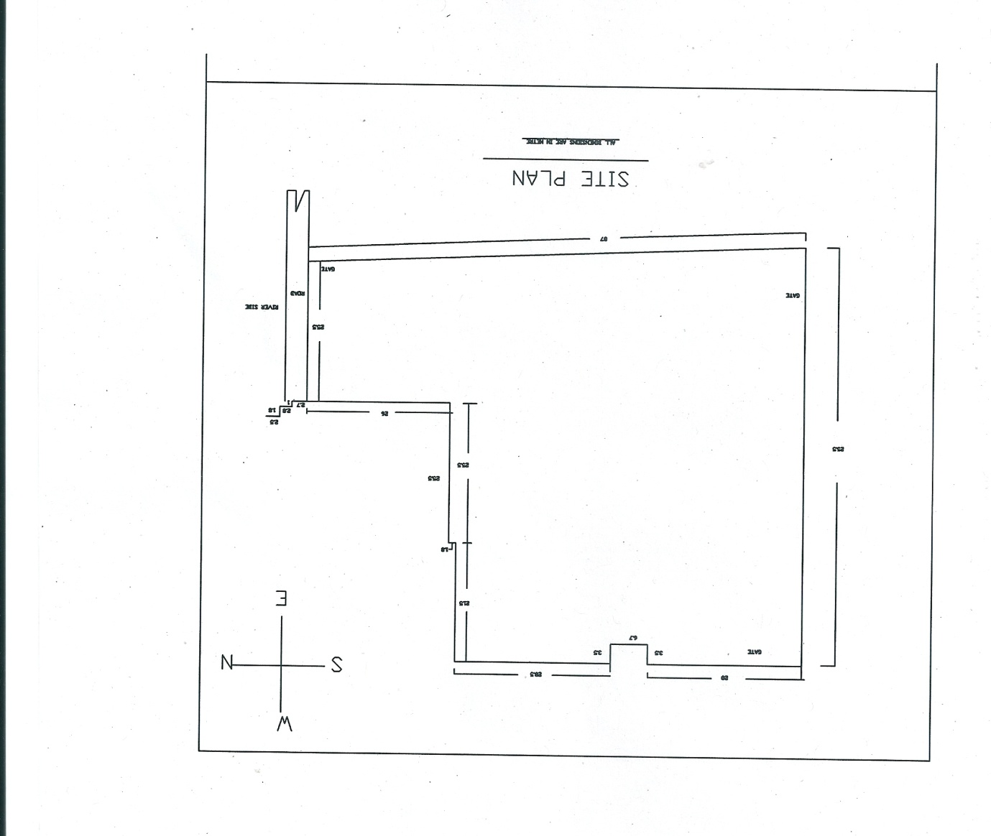
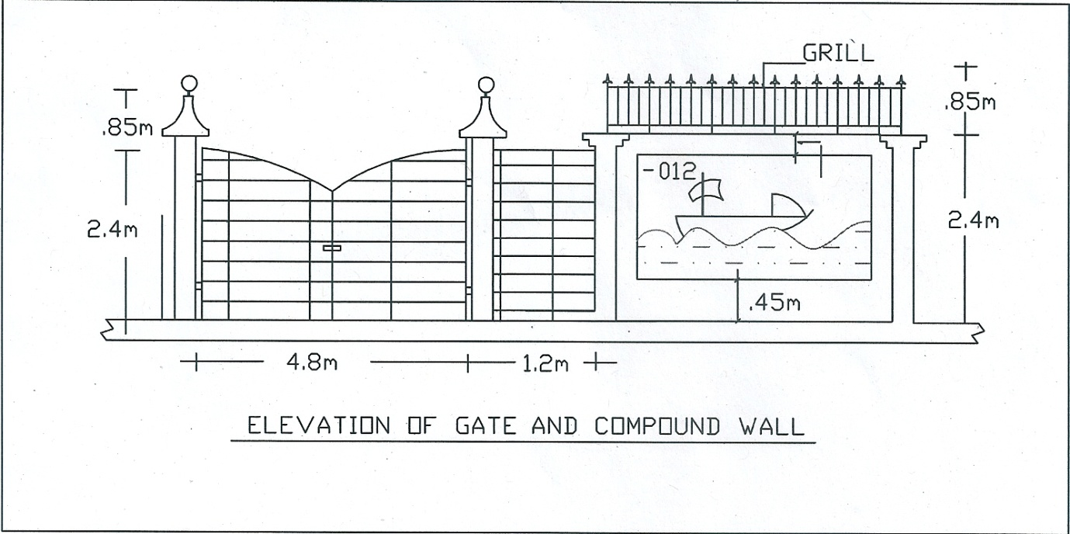

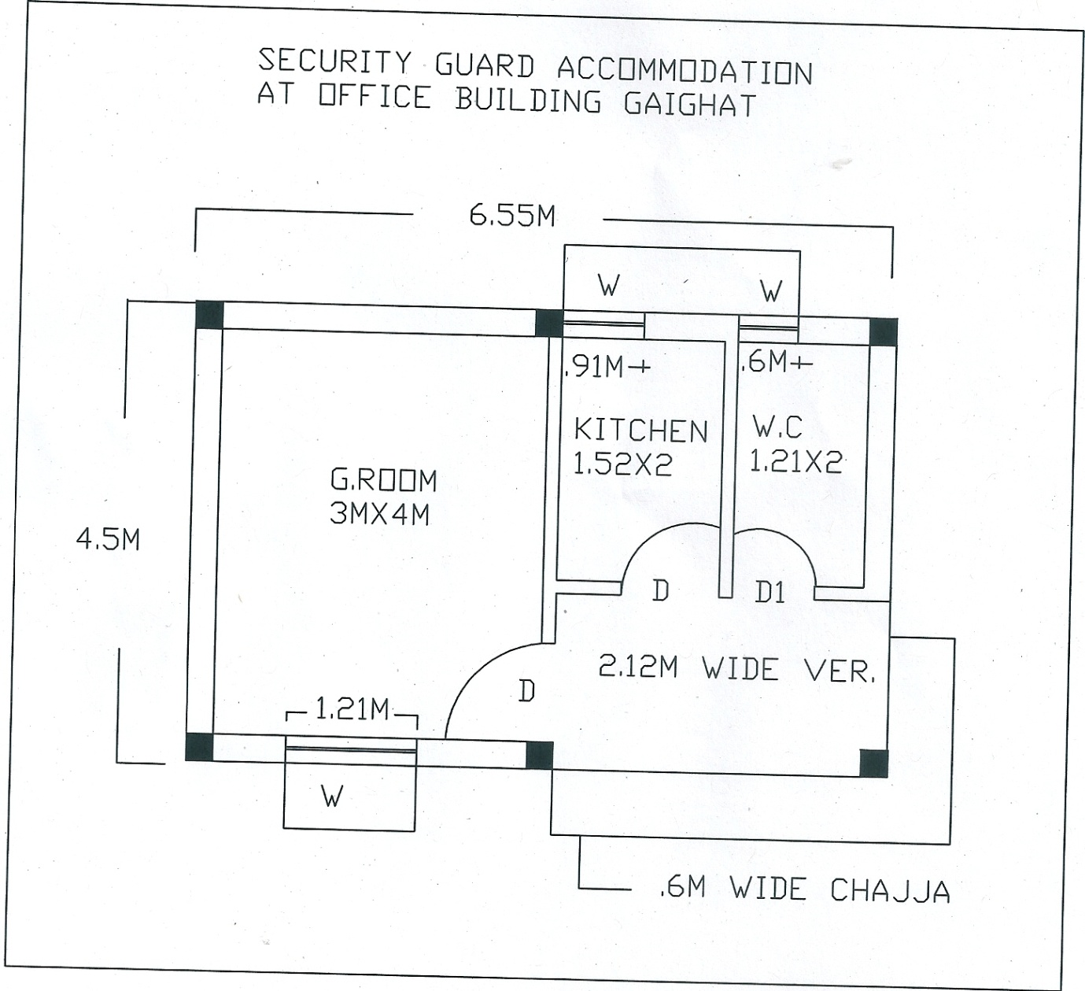
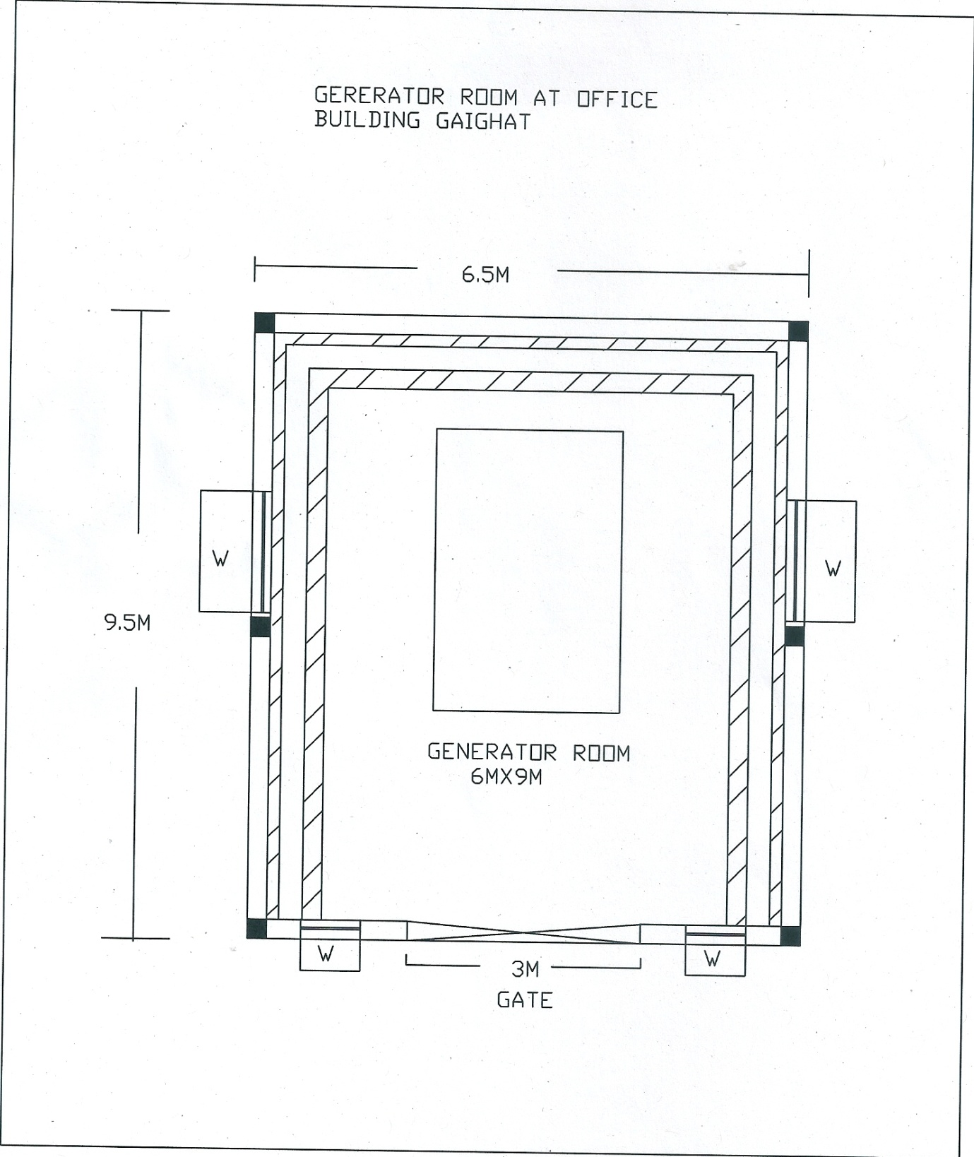

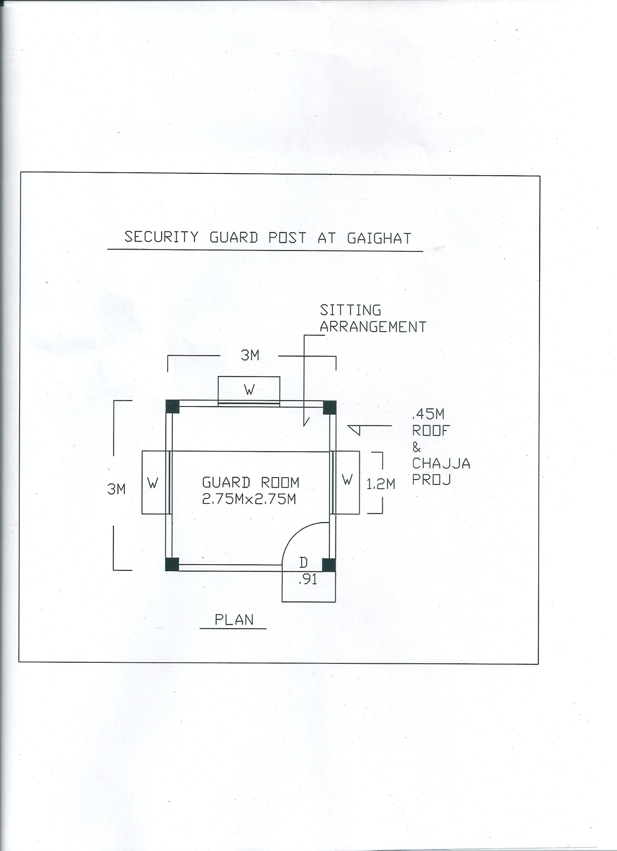

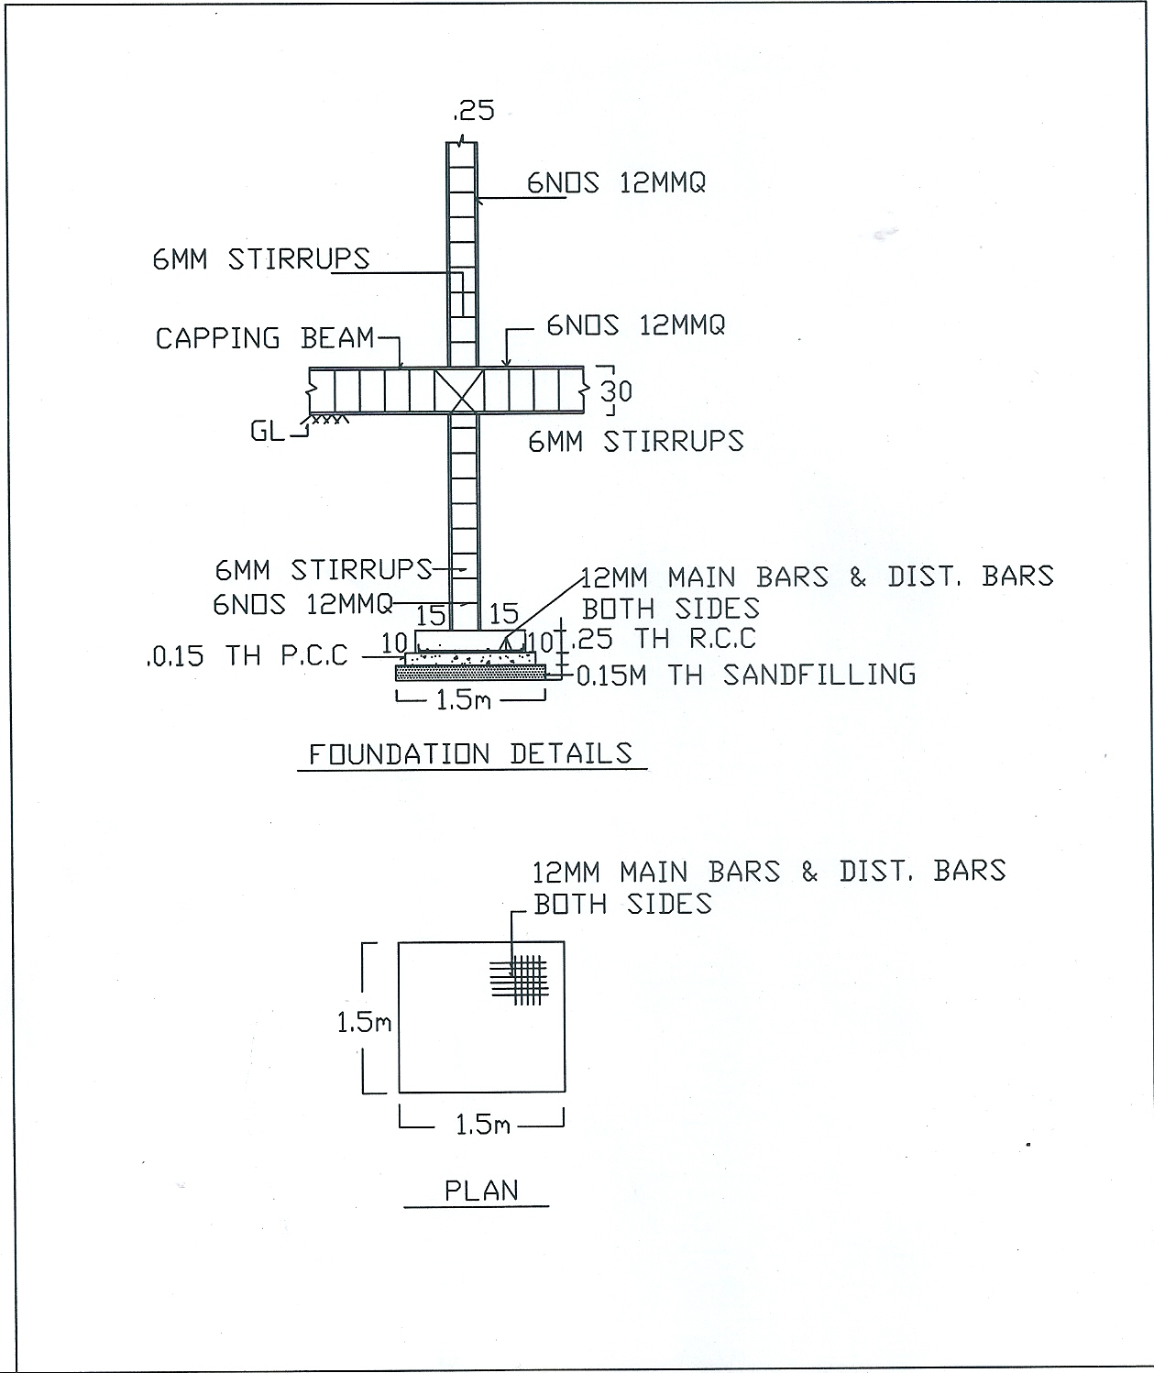

Construction of Boundary wall & Security guard post at Munger terminal.

PART – B

PRICE BID

SCHEDULE / BILL OF QUANTITIES
Construction of Boundary wall & Security Guard post at Munger terminal.
Sl.No. | Description of Items | Qty | Unit | Rate (Rs) | Amount (Rs)
1 | Boring, providing and installing bored cast-in-situ reinforced cement concrete piles of grade M-25 of specified diameter and length below the pile cap, to carry a safe working load not less than specified, excluding the cost of steel reinforcement but including the cost of boring, with bentonite solution and temporary casing of appropriate length for setting out and removal of same and the length of the pile to be embedded in the pile cap etc all complete, including removal of excavated earth with all lifts and leads (Length of pile for payment shall be measured upto bottom of pile cap)  In boundary wall 837 m + security post 24 m = 861 m | 861 | m
2 | Providing and laying in position specified grade of reinforced cement concrete, excluding the cost of centering, shuttering, finishing and reinforcement – all work up to plinth level: 1:1.5:3 (1 cement: 1.5 coarse sand : 3 graded stone aggregate 20 mm nominal size)  In boundary wall 90.70 cum + security post 5.608cum = 96.308cum | 96.308 | Cum
3 | Brick work with common burnt clay FPS (non modular) brick of class designation 7.5 in foundation and plinth in Cement morter 1:4 (1 cement : 4 coarse sand)  In boundary wall 149.10 cum + security post 2.195 cum = 151.295 cum | 151.295 | Cum
4 | Half brick work with common burnt clay FPS (non modular) brick of class designation 7.5 in foundation and plinth in Cement morter 1:3 (1 cement : 3 coarse sand)  security post 33.99 sqm | 33.99 | sqm
5 | Supplying and filling in plinth with jamuna sand including watering, ramming, consolidating and dressing all complete.  In security post 4.53 cum | 4.53 | cum
6 | Supplying and fixing of 10 mm sq bars for grill 113.71 kg each as per drawing and direction of EIC in boundary wall | 15691.98 | Kg
7 | Supplying, fitting & fixing of angle frame 25x25x5 mm for door 300 kg (16 guage) as per drawing and direction of EIC in boundary wall | 300.00 | Kg
8 | Supplying fitting and fixing in position reinforcement bars conforming to relevents IS code for RCC work including cutting, binding to proper shape and length as per drawing & direction of EIC  In boundary wall 8911.57 kg + In security post 550.86 kg= 9462.43 kg | 9462.43 | kg
9 | 15 mm thick plaster on rough side of single or half brick wall 1:4 cement morter  In boundary wall 1634.75 sqm + security post 117.97 sqm = 1752.72 sqm | 1752.72 | sqm
10 | Painting: Wall paint two coat with aerylic emulsion approved brand(Asian paints/Berger paint) on new surface to give shade althroughly brushing surface free from mortar dropping all complete job  In boundary wall 1634.75 sqm + security post 117.97 sqm = 1752.72 sqm | 1752.72 | Sqm
11 | Painting of gate by approved quality metallic paint including priming coat of approved steel primer | 1 | Job
12 | Centering and shuttering including strutting, propping all and removal of formwork all complete job as per direction of EIC  In boundary wall 576.00 sqm + 37.60 sqm = 613.6 sqm | 613.6 | sqm
13 | Supplying and fixing of sq bars for window 50 kg each including angle frame 25x25x5 mtr for door 70 kg -16 guage and frame 50x50x5 mm (in boundary wall) | 220.00 | kg
14 | Providing & fixing glass panes with putty and glazing clips in steel doors, windows c/w all complete job Glass pannel 4 mm thick (in boundary wall) | 5.40 | sqm
15 | Cement concrete flooring 1:2:4 (1 cement : 2 coarse sand : 4 graded stone aggregate) finished with a floating coat of neat cement , including cement slurry, but excluding the cost of nosing of steps etc. complete. 40 mm thick with 20 mm nominal size stone aggregate (in boundary wall) | 7.56 | sqm
16 | Painting of steel work (door & window) by approved quality of metallic paint including a priming coat of approved steel primer as per direction of EIC | 1 | Job
17 | Electrical fitting, including approved brand of fan & wire, etc. all complete Job as per direction of EIC | 1 | Job
 |  |  |  | Total
(Rupees ---------------------------------

*********

End of pages
(2 to 69 = Total 68 pages)

